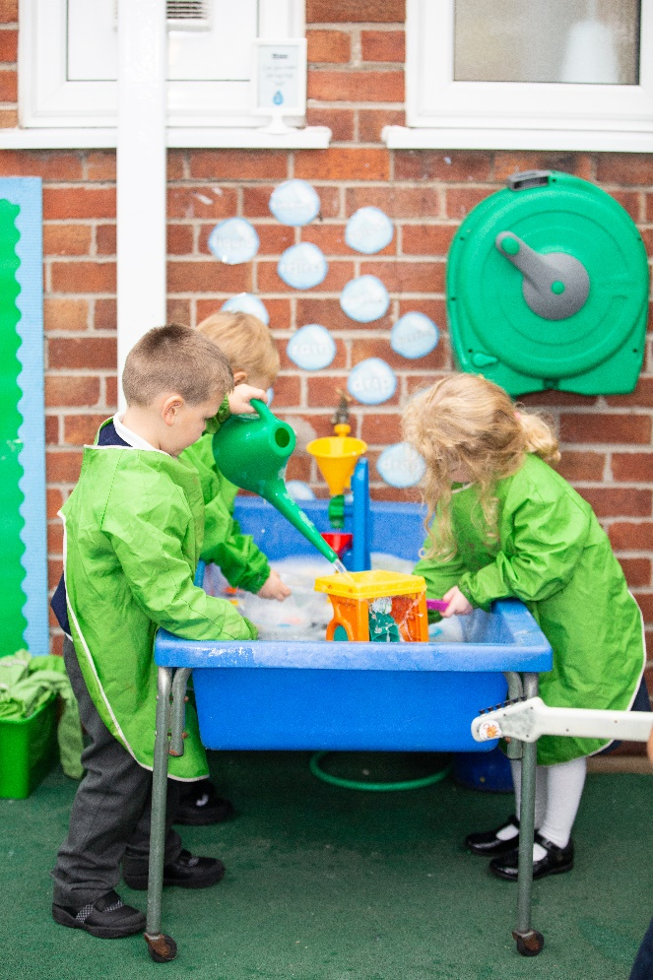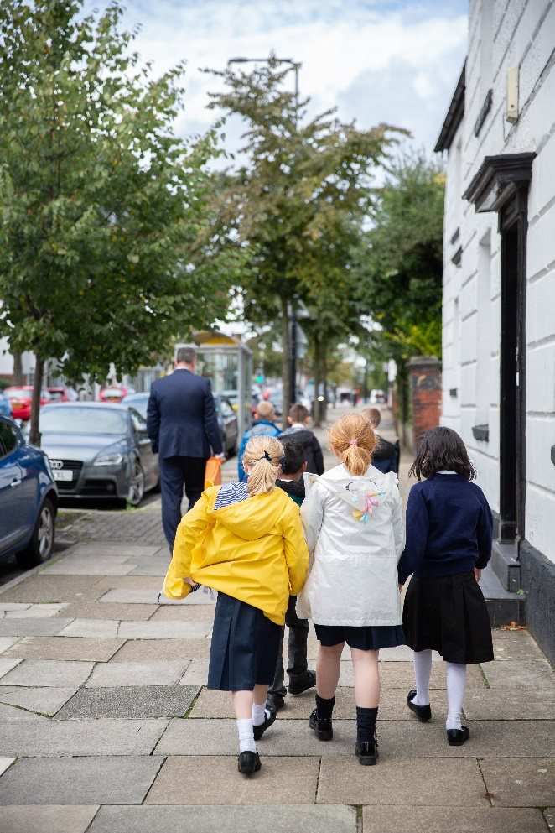
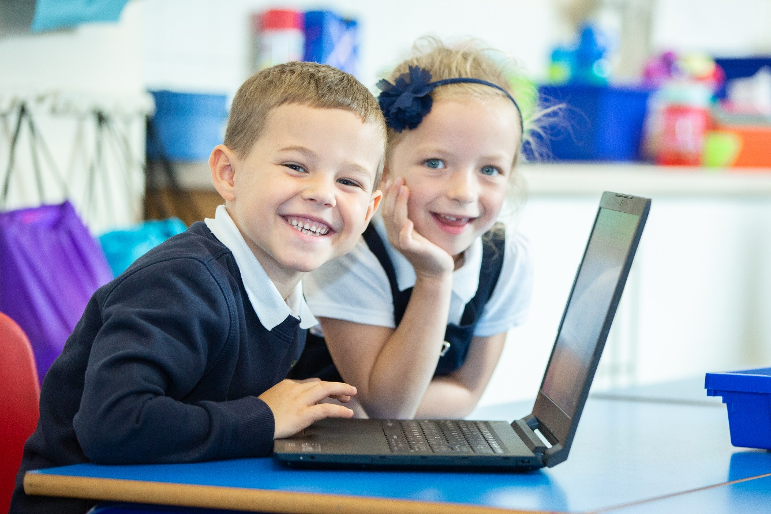

PSHE
(Personal, Social, Health Education) Policy
(including Relationships and Health Education statutory from September 2020, and our position on Sex Education )

january 2022

Contents:

1 | Statement of Intent
2 | Legal Framework
3 | Role and Responsibilities
4 | Curriculum Objectives and Subject Content
5 | Equal opportunities
6 | Cross-curricular links
7 | Health and Safety
8 | Teaching and learning
9 | Planning
10 | Assessment and reporting
11 | Monitoring and review

Appendices

Appendix 1- Relationships Education in Primary schools – DfE Guidance 2019
Appendix 2-3-11 PSHE/RSE Framework St Peters CE Primary School
Appendix 3- A CHARTER FOR FAITH SENSITIVE AND INCLUSIVE RELATIONSHIPS EDUCATION,
RELATIONSHIPS AND SEX EDUCATION (RSE) AND HEALTH EDUCATION (RSHE)

1.Statement of Intent

All schools must provide a curriculum that is broadly based, balanced and meets the needs of all pupils. Under section 78 of the Education Act 2002 and the Academies Act 2010, a PSHE curriculum:
- Promotes the spiritual, moral, cultural, mental and physical development of pupils at the school and of society, and
- Prepares pupils at the school for the opportunities, responsibilities and experiences of later life.

At St. Peter’s C.E Primary School, we teach Personal, Social, Health Education as a whole-school approach to underpin children’s development as people and because we believe that this also supports their learning capacity.

The Jigsaw Programme offers us a comprehensive, carefully thought-through Scheme of Work which brings consistency and progression to our children’s learning in this vital curriculum area.
The overview of the programme can be seen on the school website.

This also supports the “Personal Development “and “Behaviour and Attitude” aspects required under the Ofsted Inspection Framework, as well as significantly contributing to the school’s Safeguarding and Equality Duties, the Government’s British Values agenda and the SMSC (Spiritual, Moral, Social, Cultural) development opportunities provided for our children.

2. Statutory Relationships and Health Education

“The Relationships Education, Relationships and Sex Education and Health Education (England) Regulations 2019, made under sections 34 and 35 of the Children and Social Work Act 2017, make Relationships Education compulsory for all pupils receiving primary education…They also make Health Education compulsory in all schools except independent schools. Personal, Social, Health and Economic Education(PSHE) continues to be compulsory in independent schools.”
DfE Guidance p.8

“Today’s children and young people are growing up in an increasingly complex world and living their lives seamlessly on and offline. This presents many positive and exciting opportunities, but also challenges and risks. In this environment, children and young people need to know how to be safe and healthy, and how to manage their academic, personal and social lives in a positive way.”

“This is why we have made Relationships Education compulsory in all primary schools in England…as well as making Health Education compulsory in all state-funded schools.”

“In primary schools, we want the subjects to put in place the key building blocks of healthy, respectful relationships, focusing on family and friendships, in all contexts, including online. This will sit alongside the essential understanding of how to be healthy.”

“ These subjects represent a huge opportunity to help our children and young people develop. The knowledge and attributes gained will support their own, and others’ wellbeing and attainment and help young people to become successful and happy adults who make a meaningful contribution to society.”
Secretary of State Foreword DfE Guidance 2019 p.4-5

“Schools are free to determine how to deliver the content set out in the DfE guidance 2019 in the context of a broad and balanced curriculum. Effective teaching in these subjects will ensure that core knowledge is broken down into units of manageable size and communicated clearly to pupils, in a carefully sequenced way, within a planned programme of lessons.”
DfE Guidance p.8

“ All schools must have in place a written policy for Relationships Education and RSE.”
DfE Guidance p.11

Here, at St. Peter’s C.E. Primary School we value PSHE as one way to support children’s development as human beings, to enable them to understand and respect who they are, to empower them with a voice and to equip them for life and learning.

We include the statutory Relationships and Health Education within our whole-school PSHE Programme.

To ensure progression and a spiral curriculum, we use Jigsaw, the mindful approach to PSHE, as our chosen teaching and learning programme and tailor it to the children’s needs, making it personal to our school. The mapping document: Jigsaw 3-11 and statutory Relationships and Health Education, shows exactly how Jigsaw and therefore our school, meets the statutory Relationships and Health Education requirements.

This programme provides us with up to date teaching materials and ensures our teachers are well-supported, as each lesson is broken down specifically with suggested scripts.

This PSHE policy is informed by existing DfE guidance:
- Keeping Children Safe in Education (statutory guidance)
- Respectful School Communities: Self Review and Signposting Tool (a tool to support a whole school approach that promotes respect and discipline)
- Behaviour and Discipline in Schools (advice for schools, including advice for appropriate behaviour between pupils)
- Equality Act 2010 and schools
- SEND code of practice: 0 to 25 years (statutory guidance)
- Alternative Provision (statutory guidance)
- Mental Health and Behaviour in Schools (advice for schools)
- Preventing and Tackling Bullying (advice for schools, including advice on cyberbullying)
- Sexual violence and sexual harassment between children in schools (advice for schools)
- The Equality and Human Rights Commission Advice and Guidance (provides advice on avoiding discrimination in a variety of educational contexts)
- Promoting Fundamental British Values as part of SMSC in schools (guidance for maintained schools on promoting basic important British values as part of pupils’ spiritual, moral, social and cultural (SMSC)
- SMSC requirements for independent schools (guidance for independent schools on how they should support pupils' spiritual, moral, social and cultural development).
It is also aligned with the Church of England’s “A CHARTER FOR FAITH SENSITIVE AND INCLUSIVE RELATIONSHIPS EDUCATION, RELATIONSHIPS AND SEX EDUCATION (RSE) AND HEALTH EDUCATION (RSHE)” and draws on the advice given in the Church of England document ‘Valuing All God’s Children: Guidance for Church of England schools on challenging homophobic, biphobic and transphobic bullying’ (Church of England Education Office, second edition updated summer 2019).
3. Role and Responsibilities
The Jigsaw Programme is aligned to the PSHE Association Programmes of Study for PSHE.

What do we teach when and who teaches it?

Whole-school approach
Jigsaw covers all areas of PSHE for the primary phase including statutory Relationships and Health Education. The table below gives the learning theme of each of the six Puzzles (units) and these are taught across the school; the learning deepens and broadens every year.

Term | Puzzle (Unit) | Content
Autumn 1: | Being Me in My World | Includes understanding my own identity and how I fit well in the class, school and global community. Jigsaw Charter established.
Autumn 2: | Celebrating Difference | Includes anti-bullying (cyber and homophobic bullying included) and understanding difference
Spring 1: | Dreams and Goals | Includes goal-setting, aspirations, who do I want to become and what would I like to do for work and to contribute to society?
Spring 2: | Healthy Me | Includes drugs and alcohol education, self-esteem and confidence as well as healthy lifestyle choices, sleep, nutrition, rest and exercise
Summer 1: | Relationships | Includes understanding friendship, family and other relationships, conflict resolution and communication skills, bereavement and loss
Summer 2: | Changing Me | Includes Relationships and Sex Education in the context of coping positively with change

At St. Peter’s C.E. Primary School we allocate specific teaching time to PSHE each week in order to teach the PSHE knowledge and skills in a developmental and age-appropriate way.
These explicit lessons are reinforced and enhanced in many ways:
Assemblies and collective worship, praise and reward system, learning charter, pastoral support, cross curricular links e.g. science, ICT, PE, through relationships child to child, adult to child and adult to adult across the school. We aim to ‘live’ what is learnt and apply it to everyday situations in the school community.
Class teachers or HLTA’s deliver the weekly lessons to their own classes, where possible.
The subject leader is responsible for:
- Preparing school policy documents
- Reviewing changes to the PSHE/RSE scheme of work
- Monitoring the teaching and learning of PSHE/RSE and providing support where necessary
- Ensuring continuity and progression from each year group
- Helping to develop colleages ex[ertise in PSHE/RSE
- Oragnising the deployment of resources
- Liasing with teaching staff
- Communicating developments in the teaching of PSHE ans RSE
- Leading staff meetings and organising appropriate training
- Ensuring common standards are met for assessing and reviewing
- Advising on the contribution of PSHE and RSE to other curriculum areas, including cross curriucular links
- Collating assessment data and setting new priorities for the development of PSHE/RSE, on the Action plan
The SENDCO is responsible for:
- Organising training for staff regarding the curriculum for pupils with SEND
- Advising staff on how best to support pupils’ needs
- Advising staff on the inclusion of PSHE/RSE in pupil’s support plans, if necessary
- Advising staff on the use of Tas to meet the pupils’ needs

4. Curriculum Objectives and Subject Content
Relationships Education
What does the DfE statutory guidance on Relationships Education expect children to know by the time they leave primary school?
Relationships Education in primary schools will cover ‘Families and people who care for me’, ‘Caring friendships’, ‘Respectful relationships’, ‘Online relationships’, and ‘Being safe’.
The expected outcomes for each of these elements can be found further on in this policy. The way the Jigsaw Programme covers these is explained in the mapping document: Jigsaw 3-11 and Statutory Relationships and Health Education.
It is important to explain that whilst the Relationships Puzzle (unit) in Jigsaw covers most of the statutory Relationships Education, some of the outcomes are also taught elsewhere in Jigsaw e.g. the Celebrating Difference Puzzle helps children appreciate that there are many types of family composition and that each is important to the children involved. This holistic approach ensures the learning is reinforced through the year and across the curriculum.
Parents should also be aware that the Church of England states in “Valuing All God’s Children”, 2019, that Relationships and Sex education should: “Make it clear that relationships and sex education is designed to prepare all pupils for the future, regardless of sexual orientation or gender identity. RSE must promote gender equality and LGBT equality and it must challenge discrimination. RSE must take the needs and experiences of LGBT people into account and it should seek to develop understanding that there are a variety of relationships and family patterns in the modern world.” (Page 34)

Health Education
What does the DfE statutory guidance on Health Education expect children to know by the time they leave primary school?
Health Education in primary schools will cover ‘Mental wellbeing’, ‘Internet safety and harms’, Physical health and fitness’, Healthy eating’, ‘Drugs, alcohol and tobacco’, ‘Health and prevention’, ‘Basic First Aid’ and the ‘Changing adolescent body’.
The expected outcomes for each of these elements can be found further on in this policy. The way the Jigsaw Programme covers these is explained in the mapping document: Jigsaw 3-11 and Statutory Relationships and Health Education.
It is important to explain that whilst the Healthy Me Puzzle (unit) in Jigsaw covers most of the statutory Health Education, some of the outcomes are taught elsewhere in Jigsaw e.g. emotional and mental health is nurtured every lesson through the Calm me time, social skills are grown every lesson through the Connect us activity and respect is enhanced through the use of the Jigsaw Charter.
Also, teaching children about puberty is now a statutory requirement which sits within the Health Education part of the DfE guidance within the ‘Changing adolescent body’ strand, and in Jigsaw this is taught as part of the Changing Me Puzzle (unit).
Again, the mapping document transparently shows how the Jigsaw whole-school approach spirals the learning and meets all statutory requirements and more.

Sex Education
The DfE Guidance 2019 (p.23) recommends that all primary schools ‘have a sex education programme tailored to the age and the physical and emotional maturity of the pupils.
However, ‘Sex Education is not compulsory in primary schools’. (p. 23)
Schools are to determine the content of sex education at primary school. Sex education ‘should ensure that both boys and girls are prepared for the changes that adolescence brings and – drawing on knowledge of the human life cycle set out in the national curriculum for science - how a baby is conceived and born’.
At St. Peter’s C.E. Primary School, we believe children should understand the basic facts about human reproduction before they leave primary school. We define Sex Education as understanding human reproduction, from conception to birth.
We intend to continue to teach this as part of our science curriculum, but build on children’s knowledge in some specific PSHE lessons.

Parents’ right to request their child be excused from Sex Education
“Parents have the right to request that their child be withdrawn from some or all of sex education delivered as part of statutory Relationships and Sex Education” DfE Guidance p.17
At St. Peter’s C.E. Primary School, puberty is taught as a statutory requirement of Health Education and covered by our Jigsaw PSHE Programme in the ‘Changing Me’ Puzzle (unit).
We conclude that sex education refers to Human Reproduction, and therefore inform parents of their right to request their child be withdrawn from the PSHE lessons that explicitly teach this, in the Jigsaw ‘Changing Me’ Puzzle in summer term 2.
Year 3- Lesson 2 – (How babies grow in the uterus)
Year 5- Lesson (Inside body changes)
Year 6, Lesson 3 (Babies-Conception to birth)

The school will inform parents of this right by letter and breakdown of coverage (mapping) in Spring Term before the Changing Me Puzzle is taught.

5. Equal opportunities

We are an inclusive school that ensures all pupils are provided with equal learning opportunities, regardless of social class, gender, culture, race, disabilitycor learning difficulties. Our Equal Opporunites Policy ensures all pupils are able to achieve their potential in all areas of the curriculum.

Jigsaw is written as a universal core PSHE curriculum provision for all children. Inclusivity is a key part of its philosophy. Teachers tailor each Piece to meet the needs of the children in their class. To support this differentiation, many Jigsaw Pieces suggest creative learning activities that allow children to choose the media with which they work.

Equality
The DfE Guidance 2019 (p. 15) states, “Schools should ensure that the needs of all pupils are appropriately met, and that all pupils understand the importance of equality and respect. Schools must ensure they comply with the relevant provisions of the Equality Act 2010 under which sexual orientation and gender reassignment are amongst the protected characteristics…

At the point at which schools consider it appropriate to teach their pupils about LGBT (Lesbian, Gay, Bisexual, Transgender), they should ensure this content is fully integrated into their programmes of study for this area of the curriculum rather than delivered as a stand-alone unit or lesson. Schools are free to determine how they do this, and we expect all pupils to have been taught LGBT content at a timely point as part of this area of the curriculum”.

This can also have an impact on any anti-bullying policies in regard to these characteristics being the reason for the issue. The Church of England document “Valuing all God’s Children”, 2019, states:
“Schools should ensure that they have clear anti-bullying policies on preventing and tackling homophobic, biphobic and transphobic behaviour and language and that these policies are known and understood by all members of the school community. School leaders should present a clear message that HBT bullying will not be tolerated and that there can be no justification for this negative behaviour based on the Christian faith or the Bible. Schools should ensure that pupils understand how to report incidents. Pupils should be confident that if they report bullying it will be taken seriously."

It also asserts:

“Central to Christian theology is the truth that every single one of us is made in the image of God. Every one of us is loved unconditionally by God. We must avoid, at all costs, diminishing the dignity of any individual to a stereotype or a problem. Church of England schools offer a community where everyone is a person known and loved by God, supported to know their intrinsic value” (page 1)

“Opportunities to discuss issues to do with self-esteem, identity and bullying, including HBT (homophobic, biphobic and transphobic) bullying, should be included in physical, social, health and economic education or citizenship programmes. The curriculum should offer opportunities for pupils to learn to value themselves and their bodies. Relationships and sex education should take LGBT people into account.” (Page 6)

At St. Peter’s C.E. Primary School we promote respect for all and value every individual child.
We also respect the right of our children, their families and our staff, to hold beliefs, religious or otherwise, and understand that sometimes these may be in conflict with our approach to some aspects of Relationships, Health and Sex Education.

For further explanation as to how we approach LGBT relationships in the PSHE (RSHE) Programme please see:
‘Including and valuing all children. What does Jigsaw teach about LGBTQ relationships?’

‘Valuing All God’s Children’ can be found on the school website.

6. Cross Curricular Opportunities

6.1 English:
PSHE/RSE enhances English through spoken language by:
● Participating in discussion, taking turns and listening to what others say
● Asking relevant questions to extend their knowledge and understanding
● Listening and responding appropriately to adults
● Providing opportunities for pupils to discuss feelings and emotions
● Providing opportunities for pupils to consider and evaluate different opinions
● Using discussions as a way of exploring ideas and viewpoints

PSHE and RSE enhances English through writing and reading by:
● Providing opportunities for pupils to write for real purposes and audiences.
● Developing descriptive writing based on first-hand experiences, through artefacts, drama, role play, dance and art
● Writing opportunities such as : E Safety poster
● Providing opportunities for pupils to write a simple account about their experiences, how they felt, considering the need to respect beliefs and worldviews
● Using persuasive writing for example in booklets to encourage people not to smoke etc.
● Developing a respect for different cultures and written text

6.2 Mathematics:

PSHE and RSE enhances Mathematics by giving pupils opportunities to:
- Calculate growth in months or years
- Look at timelines of growth and change

6.3 Computing:

PSHE and RSE enhances Computing by giving pupils opportunities to:
● Use digital text and graphics in their work
● Take photographs when experiencing visits
● Interview and video visitors
● Use technology such as ipads and laptops to research
● Use technology to design and print posters

6.4 Art and Design:

PSHE and RSE enhances Art and Design by giving pupils opportunities to:
● Use colour, pattern, line, shape and texture
● Use and develop drawing skills when designing
● Explore a range of media and materials creatively
● Create 3D structures to represent objects and add to displays
● Discuss differences and similarities in families and people and how these can be portrayed through art

6.5 Geography:

PSHE and RSE enhances Geography by giving pupils opportunities to:

● Learn about where religions and beliefs originated
● Have a greater understanding of different cultures and travel

6.6 Science:

PSHE and RSE enhances Science by giving pupils opportunities to:

● Discuss the world, through Humanism, with no supernatural side, with the freedom to shape our own lives
● Discuss views on ethics, ‘do we need to be assigned a gender?’
● Learn about new life, seeds, buds, plants, growth, seasons
● Learn about how we grow and develop

6.7 History:

PSHE and RSE enhances History by giving pupils opportunities to:

● Look at artefacts and discuss their meanings, have they changed over time?
● Use a timeline
● Discuss significant events in History and learn about People who made significant change
● Learn about significant festivals and their history

7.Health and Safety
- Risk assessments are required and will be assessed by the class teacher and subject leader before visits
- Appropriate teacher/child ratios will be adhered to
- PPE will be worn as per government guidance
- Artefacts and objects will be used and handles with due care and attention

8. Teaching and Learning
PSHE and RSE lessons are delivered each week for pupils in Early Years, KS1 and KS2. It is important that time is spent on a weekly basis to come together and reflect.

8.2 The school uses a variety of teaching and learning styles in the lessons that are matched to the activity and ability of pupils. The main aim of these lessons is to develop pupils’ knowledge, skills and understanding.

8.3 Teaching and learning styles are adapted to support pupils with SEND to ensure these pupils continue to have their confidence and self-esteem raised.

8.4 Teachers ensure pupils apply their knowledge and understanding reflecting upon prior learning experiences.

8.5 The school uses a mixture of whole-class teaching, group work and individual activities. Pupils are given the opportunity to work independently or collaborate with others, listening to the ideas of others and treating these with respect. There are also times when cohorts are divided by gender to cover more sensitive topics.

8.6 Principles for effective teaching include:

● Setting tasks in the context of pupils’ prior knowledge – revisiting prior learning
● Promoting active learning
● Inspiring, exciting and motivating pupils to know more.

8.7 Strategies for effective teaching include:

● Ensuring the teaching methods used suit the purpose and needs of the pupils
● Providing a meaningful context and clear objectives when assigning tasks
● Ensuring activities are based on developing skills and understanding.

8.8 The classroom teacher will work with the subject leader to ensure that the needs of all pupils are met by:

● Setting tasks from the scheme which can have a variety of creative and innovative responses.
● Providing resources of differing complexity, according to the ability of the pupils.
● Setting tasks of varying difficulty, allowing challenge for all.
● Utilising support staff to ensure that pupils are effectively supported.

8.9 Evidencing Learning:

Work can be evidenced through the following:
● Written work – samples to be displayed in the Jigsaw Journal floor book, shared with our reflective Journal
● Art and design
● Photographs
● Videos of drama and role play
● Displays of good examples of labelled work
● Notes; discussion points on post-it notes can be kept in the class floor book
● Tapestry or Marvellous Me

8.10 Evidencing work is essential as it is a record of pupils’ experiences and ideas throughout a year and key stage, and will be seen as evidence for assessment and reporting purposes.

8.11 Displays:
● Displays of work are used to celebrate achievement and support teaching and learning.
● The school promotes displays of work in classrooms and corridors to influence how pupils feel about their environment, promote high expectations and raise self-esteem.
● Displays are used to communicate ideas, stimulate interest, celebrate pupils’ work, reflect the ethos of the school and respond to pupils’ interests.

9. Planning
St Peters follow the Jigsaw scheme of work and planning documents. Teachers tailor and adapt these lessons and resources to meet the needs of the pupils in their care.

10. Assessment and Reporting

Teachers ensure children are making progress with their learning throughout their Jigsaw experience.
Each lesson has a formative assessment activity that children can use to self/peer assess and show understanding in that lesson.
The last Piece (lesson) in each Puzzle is also identified as an assessment opportunity for the whole Puzzle.
At the end of each Puzzle, teachers can the use work, the floorbook and their own observations throughout the unit (Puzzle), the children’s formative assessments and Piece (lesson) 6 to make a Summative Assessment of the children’s progress.
To support the teacher in tracking each child, there is a Summative Assessment: tracking pupil progress sheet. This sheet has three attainment descriptors for each Puzzle. The teacher can then use a ‘best-fit’ approach to decide whether the child is working towards, working at or working beyond for that Puzzle, highlighting one green and one purple descriptor. The green descriptors will also flag up children who may need more support with emotional literacy or social skills development and they can be signposted to the setting’s pastoral support systems as appropriate.
In Piece (lesson) 6 there are also exemplifications to aid teacher judgement for the working towards/ working at/working beyond attainment descriptors.
Attainment is then added to the excel spreadsheet for PSHE and RSE, in order to track childrens progress over the year.

11. Monitoring and Review
The subject leader will monitor PSHE and RSE through learning walks, work samples and pupil voice, and report to the headteacher and members of SLT.
All members of staff directly involved with teaching PSHE and RSE are required to familiarise themselves with this policy.

The school and governing body will monitor this policy on an annual basis. We give serious consideration to any comments from parents about the PSHE (RSHE) programme, and make a record of such comments. This framework has been adapted using parent feedback through an online survey, in which 121 parents responded. Governors scrutinise and ratify teaching materials to check they are in accordance with the school’s ethos.

Policy Review
This policy is reviewed annually.
 | Signed Headteacher | Signed Chair of Governors
Date of review:
July 2021
Date of next review:

Jigsaw PSHE documents needed to explain this policy:
- Jigsaw 3-11 and statutory Relationships and Health Education- St Peter’s C.E. Primary School Framework (mapping document)
- Including and valuing all children. What does Jigsaw teach about LGBTQ relationships?
- How does Jigsaw PSHE support the Church of England Principles and Charter in relation to RSHE?
- The Church of England Charter- St Peter’s C.E. Primary School

Appendix 1
Relationships Education in Primary schools – DfE Guidance 2019
The focus in primary school should be on teaching the fundamental building blocks and characteristics of positive relationships, with particular reference to friendships, family relationships, and relationships with other children and with adults.
The guidance states that, by the end of primary school:
 | Pupils should know… | How Jigsaw provides the solution
Families and people who care for me | - that families are important for children growing up because they can give love, security and stability.  - the characteristics of healthy family life, commitment to each other, including in times of difficulty, protection and care for children and other family members, the importance of spending time together and sharing each other’s lives.  - that others’ families, either in school or in the wider world, sometimes look different from their family, but that they should respect those differences and know that other children’s families are also characterised by love and care.  - that stable, caring relationships, which may be of different types, are at the heart of happy families, and are important for children’s security as they grow up.  - that marriage represents a formal and legally recognised commitment of two people to each other which is intended to be lifelong (Marriage in England and Wales is available to both opposite sex and same sex couples. The Marriage (Same Sex Couples) Act 2013 extended marriage to same sex couples in England and Wales. The ceremony through which a couple get married may be civil or religious).  - how to recognise if family relationships are making them feel unhappy or unsafe, and how to seek help or advice from others if needed.  - about different types of bullying (including cyberbullying), the impact of bullying, responsibilities of bystanders (primarily reporting bullying to an adult) and how to get help.  - what a stereotype is, and how stereotypes can be unfair, negative or destructive.  - the importance of permission-seeking and giving in relationships with friends, peers and adults. | All of these aspects are covered in lessons within the Puzzles  - Relationships  - Changing Me  - Celebrating Difference  - Being Me in My World
Online relationships | - that people sometimes behave differently online, including by pretending to be someone they are not.  - that the same principles apply to online relationships as to face-to-face relationships, including the importance of respect for others online including when we are anonymous.  - the rules and principles for keeping safe online, how to recognise risks, harmful content and contact, and how to report them.  - how to critically consider their online friendships and sources of information including awareness of the risks associated with people they have never met.  - how information and data is shared and used online. | All of these aspects are covered in lessons within the Puzzles  - Relationships  - Changing Me  - Celebrating Difference
Being safe | - What sorts of boundaries are appropriate in friendships with peers and others (including in a digital context).  - about the concept of privacy and the implications of it for both children and adults; including that it is not always right to keep secrets if they relate to being safe.  - that each person’s body belongs to them, and the differences between appropriate and inappropriate or unsafe physical, and other, contact.  - how to respond safely and appropriately to adults they may encounter (in all contexts, including online) whom they do not know.  - how to recognise and report feelings of being unsafe or feeling bad about any adult.  - how to ask for advice or help for themselves or others, and to keep trying until they are heard,  - how to report concerns or abuse, and the vocabulary and confidence needed to do so.  - where to get advice e.g. family, school and/or other sources. | All of these aspects are covered in lessons within the Puzzles  - Relationships  - Changing Me  - Celebrating Difference

Physical health and mental well-being education in Primary schools – DfE Guidance
The focus in primary school should be on teaching the characteristics of good physical health and mental wellbeing. Teachers should be clear that mental well-being is a normal part of daily life, in the same way as physical health.
By the end of primary school:
 | Pupils should know | How Jigsaw provides the solution
Mental wellbeing | - that mental wellbeing is a normal part of daily life, in the same way as physical health.  - that there is a normal range of emotions (e.g. happiness, sadness, anger, fear, surprise, nervousness) and scale of emotions that all humans experience in relation to different experiences and situations.  - how to recognise and talk about their emotions, including having a varied vocabulary of words to use when talking about their own and others’ feelings.  - how to judge whether what they are feeling and how they are behaving is appropriate and proportionate.  - the benefits of physical exercise, time outdoors, community participation, voluntary and service-based activity on mental well-being and happiness.  - simple self-care techniques, including the importance of rest, time spent with friends and family and the benefits of hobbies and interests.  - isolation and loneliness can affect children and that it is very important for children to discuss their feelings with an adult and seek support.  - that bullying (including cyberbullying) has a negative and often lasting impact on mental well-being.  - where and how to seek support (including recognising the triggers for seeking support), including whom in school they should speak to if they are worried about their own or someone else’s mental well-being or ability to control their emotions (including issues arising online).  - it is common for people to experience mental ill health. For many people who do, the problems can be resolved if the right support is made available, especially if accessed early enough. | All of these aspects are covered in lessons within the Puzzles  - Healthy Me  - Relationships  - Changing Me  - Celebrating Difference
Internet safety and harms | - that for most people the internet is an integral part of life and has many benefits.  - about the benefits of rationing time spent online, the risks of excessive time spent on electronic devices and the impact of positive and negative content online on their own and others’ mental and physical wellbeing.  - how to consider the effect of their online actions on others and knowhow to recognise and display respectful behaviour online and the importance of keeping personal information private.  - why social media, some computer games and online gaming, for example, are age restricted.  - that the internet can also be a negative place where online abuse, trolling, bullying and harassment can take place, which can have a negative impact on mental health.  - how to be a discerning consumer of information online including understanding that information, including that from search engines, is ranked, selected and targeted.  - where and how to report concerns and get support with issues online. | All of these aspects are covered in lessons within the Puzzles  - Relationships  - Healthy Me
Physical health and fitness | - the characteristics and mental and physical benefits of an active lifestyle.  - the importance of building regular exercise into daily and weekly routines and how to achieve this; for example, walking or cycling to school, a daily active mile or other forms of regular, vigorous exercise.  - the risks associated with an inactive lifestyle (including obesity).  - how and when to seek support including which adults to speak to in school if they are worried about their health. | All of these aspects are covered in lessons within the Puzzles  - Healthy Me
Healthy eating | - what constitutes a healthy diet (including understanding calories and other nutritional content).  - the principles of planning and preparing a range of healthy meals.  - the characteristics of a poor diet and risks associated with unhealthy eating (including, for example, obesity and tooth decay) and other behaviours (e.g. the impact of alcohol on diet or health). | All of these aspects are covered in lessons within the Puzzles  - Healthy Me
Drugs, alcohol and tobacco | - how to recognise early signs of physical illness, such as weight loss, or unexplained changes to the body.  - about safe and unsafe exposure to the sun, and how to reduce the risk of sun damage, including skin cancer.  - the importance of sufficient good quality sleep for good health and that a lack of sleep can affect weight, mood and ability to learn.  - about dental health and the benefits of good oral hygiene and dental flossing, including regular check-ups at the dentist.  - about personal hygiene and germs including bacteria, viruses, how they are spread and treated, and the importance of handwashing.  - the facts and science relating to immunisation and vaccination | All of these aspects are covered in lessons within the Puzzles  - Healthy Me
Basic first aid | - how to make a clear and efficient call to emergency services if necessary.  - concepts of basic first-aid, for example dealing with common injuries, including head injuries. | All of these aspects are covered in lessons within the Puzzles  - Healthy Me
Changing adolescent body | - key facts about puberty and the changing adolescent body, particularly from age 9 through to age 11, including physical and emotional changes.  - about menstrual wellbeing including the key facts about the menstrual cycle. | All of these aspects are covered in lessons within the Puzzles  - Changing Me  - Healthy Me

Appendix 2
3-11 PSHE/RSE Framework St Peters CE Primary School
Year Group | Being in My  World | Celebrating Difference | Dreams and Goals | Healthy Me | Relationships | Changing Me
Rec | - Self-Identity  - Understanding feelings  - Being in a classroom  - Being gentle  - Right and responsibilities | - Identifying talents  - Being special  - Families  - Where we live  - Making friends  - Standing up for yourself | - Challenges  - Perseverance  - Goal setting  - Overcoming obstacles  - Seeking help  - Jobs  - Achieving goals | - Exercising bodies  - Physical activity  - Healthy food  - Sleep  - Keeping clean  - Safety | - Family life  - Friendships  - Breaking friendships  - Falling out  - Dealing with bullying  - Being a good friend | - Bodies  - Respecting my body  - Growing up  - Growing and change  - Fun and fears  - Celebrations  (All pieces)
Yr 1 | - Feeling special and safe  - Being part of a class  - Rights and responsibilities  - Rewards and feeling proud  - Consequences  - Owning the learning charter | - Similarities and differences  - Understanding bullying and knowing how to deal with it  - Making new friends  - Celebrating the differences in everyone | - Setting goals  - Identifying successes and achievements  - Learning styles  - Working well and celebrating achievement with a partner.  - Tackling new challenges.  - Identifying and overcoming obstacles.  - Feelings of success. | - Keeping myself healthy  - Healthier lifestyle choices  - Keeping clean  - Being safe  - Medicine safety/  safety with household items  - Road safety  - Linking healthy and happiness | - Belonging to a family  - Making friends/being a good friend  - Physical contact preferences  - People who help us  - Qualities as a friend and person  - Self-acknowledgement  - Being a good friend to myself  - Celebrating special relationships | - Life cycles- human and animal  - Changes since being a baby  - Differences between female and male bodies  (penis, vagina, vulva, testicles, anus)  - Linking growing and learning  - Coping with change  - Transition  (All pieces)
Yr 2 | - Hopes and fears for the year  - Rights and responsibilities  - Rewards and consequences  - Safe and fair learning environment  - Valuing contributions  - Choices  - Recognising feelings | - Assumptions and stereotypes about gender  - Understanding bullying  - Standing up for self and others  - Making new friends  - Gender diversity  - Celebrating differences and remaining friends | - Achieving realistic goals  - Perseverance  - Learning strengths  - Learning with others  - Group cooperation  - Contributing to and sharing success | - Motivations  - Healthier choices  - Relaxation  - Healthy eating and nutrition  - Healthier snacks and sharing food | - Different types of family  - Physical contact boundaries  - Friendship and conflict  - Secrets  - Trust and appreciation  - Expressing appreciation for special relationships | - Life cycles in nature  - Growing from young to old  - Increasing independence  - Differences in female and male bodies  - Assertiveness  - Preparing for transition  (All pieces)
Yr 3 | - Setting personal goals  - Self-identity and worth  - Positivity in challenges  - Rules, rights and responsibilities  - Rewards and consequences  - Responsible choices  - Seeing things from others’ perspectives | - Families and their differences  - Family conflict and how to manage it (child centred)  - Witnessing bullying and how to solve it  - Recognising how words can be hurtful  - Giving & receiving compliments | - Difficult challenges and achieving success  - Dreams and ambition  - New challenges  - Motivation and enthusiasm  - Recognising and trying to overcome obstacles  - Evaluating learning processes  - Managing feelings  - Simple budgeting | - Exercise  - Fitness challenges  - Food labelling and healthy swaps  - Attitudes towards drugs  - Keeping safe and why its important online and offline  - Scenarios  - Respect for myself and others  - Healthy and safe choices | - Family roles and responsibilities  - Friendship and negotiation  - Keeping safe online and who to go to for help  - Being a global citizen  - Being aware of how my choices affect others  - Awareness of how other children have different lives  - Expressing appreciation for family and friends. | - How babies grow  - Understanding a baby’s needs  - Family stereotypes  - Challenging my ideas  - Preparing for transition  (puzzle pieces 1,2,5,6)
Yr 4 | - Being part of a class/team  - Being a school citizen  - Rights, responsibilities and democracy (SC)  - Rewards and consequences  - Group decision-making  - Having a choice  - What motivates behaviour | - Challenging assumptions  - Judging by appearance  - Accepting self and others  - Understanding influences  - Understanding bullying  - Problem solving  - Identifying how special and unique everyone is  - First impressions | - Hope and dreams  - Overcoming disappointment  - Creating new, realistic dreams  - Achieving goals  - Working in a group  - Celebrating contributions  - Resilience  - Positive attitudes | - Healthier friendships  - Group dynamics  - Smoking  - Alcohol  - Assertiveness  - Peer pressure  - Celebrating inner strength | - Jealousy  - Love and Loss  - Memories of loved ones  - Getting on and falling out  - Girlfriends and boyfriends  - Showing appreciation to people and animals | - Year 3 puzzle 6, piece 3- Outside body changes  - Girls and puberty- girls only  - Circles of change  - Accepting change  - Looking Ahead  (pieces 3,4,5,6)
Yr 5 | - Planning the forthcoming year  - Being a citizen  - Rights and responsibilities  - Rewards and consequences  - How behaviour affects groups  - Democracy, having a choice, participating | - Cultural differences and how they can cause conflict  - Racism  - Rumours and name calling  - Types of bullying  - Material wealth and happiness  - Enjoying and respecting other cultures | - Future dreams  - The importance of money, jobs and careers  - Dream job and how to get there  - Goals in different cultures  - Supporting others (charity)  - Motivation | - Smoking, including vaping  - Alcohol/ Alcohol and antisocial behaviour  - Emergency aid  - Body image  - Relationships with food  - Healthy choices  - Motivation and behaviour | - Self-recognition and self-worth  - Building self esteem  - Safer online communities  - Rights and responsibilities online  - Online gaming and gambling  - Reducing screen time  - Dangers of online grooming  - SMARRT Internet Safety rules | - Year 3, puzzles 6, piece 4, Inside body changes  - Self-image  - Girls and puberty-omit language in list*  - Boys and puberty- omit language in list*  - Coping with change  - Preparing for transition  (Pieces 1,2,3,6)
Yr 6 | - Identifying goals for the year  - Global citizenship  - Children’s universal rights  - Feeling welcome and values  - Choice, consequences and rewards  - Group dynamics  - Democracy. Having a voice  - Anti-social behaviour  - Role-modelling | - Perceptions of normality  - Understanding disability  - Power struggles  - Understanding bullying  - Inclusion/exclusion  - Differences as conflict. Difference as celebration.  - Empathy | - Personal learning goals, in and out of school  - Success criteria  - Emotion in success  - Making a difference in the world  - Motivation  - Recognising achievements  - Compliments | - Taking personal responsibility  - How substances affect the body  - Exploitation, including ‘county lines’ and gang culture  - Emotional and mental health  - Manging stress | - Mental health  - Identifying mental health worries and sources to support.  - Love and loss  - Managing feelings  - Power and control  - Assertiveness  - Technology safety  - Take responsibility with technology use | - My Self image  - Puberty- girl talk/boy talk  - Babies- Conception to birth  - Real self and ideal self  - The year ahead  (Pieces 1,2,3,5,6)

*In year 1 and 2, children will discuss and label the body using terms; penis, vagina, vulva, testicles, anus, bottom. They will learn about parts of the body that are private and about appropriate touching.
*In year 3, children will learn about how babies grow inside the womb/uterus and after they are born, what they need to survive and grow.
*In year 4 children will learn about outside body changes during puberty and Yr. 4 girls will learn about the menstruation cycle and the science around this bodily function. This will further prepare them, in time for the onset of menstruation and puberty.
Terms related to puberty changes are; pubic hair, hormones, spots, breasts, penis, testicles, chest, facial hair.
Terms related to the cycle are; fallopian tubes, ovaries, uterus, vagina, cervix and vulva.
*Year 5- In year 5, children will learn about the growth of a baby and the science of the internal organs, and how their bodies change during puberty, ready to make babies. This work will complement the science National Curriculum section -The human reproduction system and puberty changes.
We agree that we will not use the terms: ejaculation, sexual intercourse, contraception as we can teach the children about basic reproduction and puberty in an age appropriate way.
*Year 6-We will build on children’s prior learning. Children will learn about the process of human reproduction from conception to birth. They will understand the changes that are taking place during puberty in themselves and the opposite sex and will discuss how to prepare for high school transition- emotionally and physically.
We agree that we will not use the terms: clitoris, wet dream, semen and masturbation. These are terms which children will meet in high school and we have deemed them as not age-appropriate for many of our primary children. Where possible, we will avoid talking about the act of human reproduction and conception as ‘having sex’, ‘sexual intercourse’ or ‘making love’ at St Peter’s CE Primary school.

All content may be shared with parents and most of the RSE is covered in the summer term.
LGBT awareness is not taught separately, but alongside all relationships lessons, in guidance with ‘Valuing All Gods Children.’ It is also touched on in the jigsaw piece, ‘celebrating difference’ where we show different family types and same sex couples, as well as exploring different types of bullying, including homophobic.

Appendix 3-
A CHARTER FOR FAITH SENSITIVE AND INCLUSIVE RELATIONSHIPS EDUCATION,
RELATIONSHIPS AND SEX EDUCATION (RSE) AND HEALTH EDUCATION (RSHE)
At St.Peter’s we seek to provide Relationships Education, Relationships and Sex Education (RSE)
and Health Education (RSHE), which will enable all pupils to flourish.
We commit:
1.To work in partnership with parents and carers.
This will involve dialogue with parents and carers through all stages of policy development as well as discussing the resources used to teach their children and how they can contribute at home. It must, however, be recognised that the law specifies that what is taught and how it is taught is ultimately a decision for the school.
2. That RSHE will be delivered professionally and as an identifiable part of PSHE.
It will be led, resourced and reported to parents in the same way as any other subject. There will be a planned programme delivered in a carefully sequenced way. Staff will receive regular training in RSHE and PSHE. Any expert visitors or trainers invited into the school to enhance and supplement the programme will be expected to respect the schools published policy for RSHE.
3. That RSHE will be delivered in a way that affords dignity and shows respect to all who
make up our diverse community.
It will not discriminate against any of the protected characteristics in the Equality Act
and will be sensitive to the faith and beliefs of those in the wider school community. RSHE will seek to explain fairly the tenets and varying interpretations of religious communities on matters of sex and relationships and teach these viewpoints with respect. It will value the importance of faithfulness as the underpinning and backdrop for relationships. It will encourage pupils to develop the skills needed to disagree without being disagreeable, to appreciate the lived experience of other people and to live well together.
4. That RSHE will seek to build resilience in our pupils to help them form healthy
relationships, to keep themselves safe and resist the harmful influence of pornography
in all its forms. It will give pupils opportunities to reflect on values and influences including their
peers, the media, the internet, faith and culture that may have shaped their attitudes to gender,
relationships and sex. It will promote the development of the wisdom and skills our pupils need to
make their own informed decisions.
RSHE is used to indicate either Relationships Education, Relationships and Sex Education and Health Education as determined by the school context since, after consultation with parents and carers primary schools may decide to include elements of sex education in their curriculum.
The protected characteristics are age, disability, gender reassignment, race, religion or belief, sex, sexual orientation, marriage and civil partnership and pregnancy and maternity.
© The Church of England Education Office November 2019
5. That RSHE will promote healthy resilient relationships set in the context of character
and virtue development.
It will reflect the vision and associated values of the school, promote reverence for the gift of human sexuality and encourage relationships that are hopeful and aspirational. Based on the school’s values it will seek to develop character within a moral framework based on virtues such as honesty, integrity, self-control, courage, humility, kindness, forgiveness, generosity and a sense of justice but does not seek to teach only one moral position.
6. That RSHE will be based on honest and medically accurate information from reliable
sources of information, including about the law and legal rights.
It will distinguish between different types of knowledge and opinions so that pupils can learn about their bodies and sexual and reproductive health as appropriate to their age and maturity.
7. To take a particular care to meet the individual needs of all pupils including those with
special needs and disabilities.
It will ensure that lessons and any resources used will be accessible and sensitive to the learning needs of the individual child. We acknowledge the potential vulnerability of pupils who have special educational needs and disabilities (SEND) and recognise the possibilities and rights of SEND pupils to high quality Relationships and Sex Education.
8. To seek pupils’ views about RSHE so that the teaching can be made relevant to their
lives.
It will discuss real life issues relating to the age and stage of pupils, including friendships, families,
faith, consent, relationship abuse, exploitation and safe relationships online. This will be carefully
targeted and age appropriate based on a teacher judgment about pupil readiness for this information in consultation with parents and carers.

