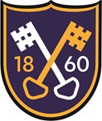

COVID-19 - In the Event of Illness Main symptoms
The main symptoms of coronavirus are:

- a high temperature – this means you feel hot to touch on your chest or back (you do not need to measure your temperature)
- a new, continuous cough – this means coughing a lot for more than an hour, or 3 or more coughing episodes in 24 hours (if you usually have a cough, it may be worse than usual)
- a loss or change to your sense of smell or taste – this means you've noticed you cannot smell or taste anything, or things smell or taste different to normal
Most people with coronavirus have at least 1 of these symptoms.

If your child displays any of these symptoms, please do not send your child to school. Similarly if any member of your household displays symptoms or is self- isolating, your child should not be in school.

What to do if you have symptoms
If you have any of the main symptoms of coronavirus:

- Get a test to check if you have coronavirus as soon as possible. The nearest place is Haydock Racecourse https://www.gov.uk/get-coronavirus-test
- Stay at home and do not have visitors until you get your test result – only leave your home to have a test.
Anyone you live with, and anyone in your support bubble, must also stay at home until you get your result. This means siblings also.

Use the NHS 111 online coronavirus service if:
- you're worried about your symptoms
- you're not sure what to do
Use the NHS 111 online coronavirus service
Call 111 if you cannot get help online. Do not go to places like a GP surgery, hospital or pharmacy.

What happens in school if a child develops symptoms?
If a child in the school becomes unwell with a new and persistent cough or a high temperature, or has a loss of or change in their normal sense of taste or smell they will be isolated in our isolation room.h

Parents will be contacted to collect their child (plus sibling) and advised to follow guidance which sets out they should self-isolate for at least 10 days and arrange to have a test to see if they have coronavirus (COVID-19). Members of their household including siblings should self-isolate for 14 days. To get a test call 119 or online https://self- referral.test-for-coronavirus.service.gov.uk/antigen/name


If they test negative then the child and sibling will be allowed to return back to school and their fellow household members can end their self-isolation.
Where the child tests positive, the school will take immediate Public Health England advice, which will most likely result in the rest of their Bubble / class being sent home and advised to self-isolate for 14 days. The other household members of that wider bubble / class do not need to self-isolate unless the child they live with in that group subsequently develops symptoms. The Bubble rooms will then be deep cleaned.

Throughout the above process, please keep school as up to date as possible.

We politely request that St Peter’s parents do not comment on social media including naming children or staff if we have positive cases, as this leads to miss information, speculation and increase anxiety.
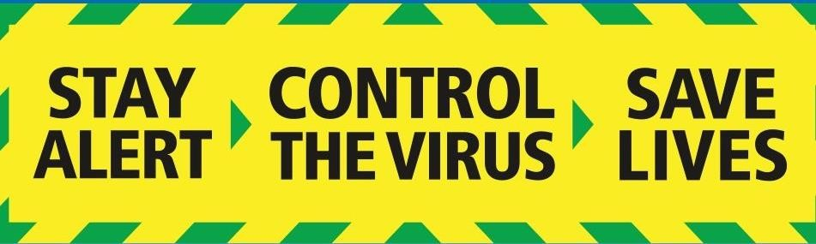

Easy to use Flowchart

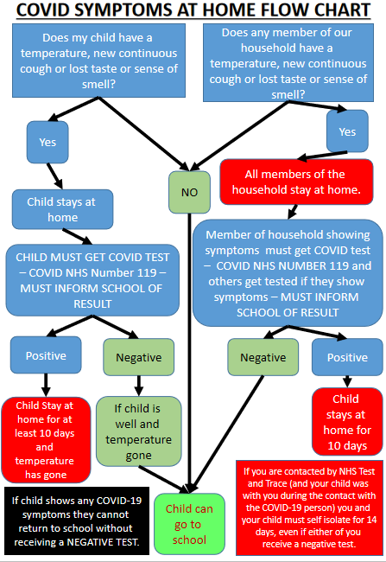

What will St Peter’s do in the event of a positive test for a pupil or teacher / teaching assistant?

- Ring Public Health England - Merseyside (receive their instructions)
- Inform Chair of Governors of PHE instructions.
- Agree communication strategy.
- Inform parents/carers of effected classes / bubble.
- Inform all remaining school parents / carers.
- Inform staff.
- Inform Governing Board.
- Arrange for class / bubble to be collected.
- Siblings at this point will not need to go home.
- Inform Little Foxes and Kitchen
- Inform other children sensitively what is happening.
- Check staff wellbeing.
- Organise work for children to do at home (remote learning)
- Deal with any press release through St Helen’s MBC and the Diocese of Liverpool.
- Issue ‘provisional’ return date.
- Deep clean classroom

Parents will not be informed who has been tested positive - this is private medical information.

What will St Peter’s do in the event of a positive test or enforced isolation for the Head Teacher (Mr Robinson)?

- The Head teacher is making just fleeting visits to classes to ensure class bubbles are not compromised.
- Inform Chair of Governors
- Deputy Head Teacher (Mrs Colley) to assume operational control of the school
- Mrs Colley and Mrs Harrison to work on a rota system to be out of class to run the school.
- Supply teachers to cover the senior leadership team classes

What will St Peter’s do in the event of a positive test or enforced isolation for the office staff?

- Supply office staff to ensure basic duties are completed
- Teaching assistant to work in the office full time to answer parent calls.
- Inform parents that the office is open for essential work only

