St Peter’s C of E Primary School
School Uniform Policy 2022

Date policy last reviewed:

Contents:
Statement of intent
- Legal framework
- Roles and responsibilities
- Cost principles
- Equality principles
- Complaints and challenges
- School uniform supplier
- Uniform assistance
- Non-compliance
- School uniform
- Adverse weather
- Labelling
- Monitoring and review

Statement of intent
St Peter’s believes that a consistent school uniform policy is vital to promote the ethos of the school and provide a sense of belonging and identity for all pupils, regardless of their protected characteristics or socio-economic circumstances.
This policy lays out the measures the school has taken to ensure a consistent, fair and inclusive uniform policy, and to implement a uniform that reflects the needs of all pupils, and is affordable and the best value for money for the school and pupils’ families.
We believe that pupils learn most effectively and achieve their best outcomes when they are comfortable, able to be themselves, and dressed in such a way that sets an appropriate tone for education.

Legal framework
This policy has due regard to all relevant legislation including, but not limited to, the following:
  - Education and Inspections Act 2006
  - Education Act 2011
  - Human Rights Act 1998
  - Equality Act 2010
  - The UK General Data Protection Regulation (UK GDPR)
  - Data Protection Act 2018
This policy has due regard to all relevant guidance including, but not limited to, the following:
  - DfE (2021) ‘Cost of school uniforms’
  - DfE (2021) ‘School Admissions Code’
  - DfE (2021) ‘School uniforms’
This policy operates in conjunction with the following school policies:
  - Complaints Procedures Policy
  - Behaviour Policy

Roles and responsibilities
The governing board is responsible for:
  - Establishing, in consultation with the headteacher and school community, a practical and smart school uniform that accurately reflects the school’s vision and values.
  - Ensuring that the school’s uniform is accessible and inclusive, and does not disadvantage any pupil by virtue of their protected characteristics or socio-economic status.
  - Listening to the opinions and wishes of parents, pupils and the wider school community regarding changes to the school’s uniform.
  - Ensuring that the school’s uniform is accessible and affordable.
  - Demonstrating how best value for money has been achieved in the uniform policy.
  - Ensuring compliance with the DfE’s ‘Cost of school uniforms’ guidance.
  - Processing and approving all eligible School Uniform Assistance Application Forms.
The headteacher is responsible for:
  - Enforcing the school’s uniform on a day-to-day basis.
  - Ensuring that teachers understand this policy and what to do if a pupil is in breach of the policy.
  - Listening to the opinions and wishes of the school community in regard to the school’s uniform and making appropriate recommendations to the governing board.
  - Providing pupils with an exemption letter as appropriate, e.g. for a pupil who has a broken arm and requires a loose-fitting top.

Staff members are responsible for:
  - Ensuring that pupils dress in accordance with this policy at all times.
  - Disciplining pupils who are in breach of this policy.
  - Ensuring that pupils understand why having a consistent and practical school uniform is important, e.g. school identity.
Parents are responsible for:
  - Providing their children with the correct school uniform as detailed in this policy.
  - Informing the headteacher if their child requires a more relaxed uniform policy for a period of time, including why.
  - Ensuring that their child’s uniform is clean, presentable and the correct size.
Pupils are responsible for:
  - Wearing the correct uniform at all times, unless the headteacher has granted an exemption.
  - Looking after their uniform as appropriate.
  - Understanding and respecting why a school uniform is important to the school, e.g. school identity and community.

Cost principles
The school is committed to ensuring that its school uniform is affordable and accessible to all pupils and does not place an unreasonable financial burden on parents.
In accordance with the ‘School Admissions Code’, the headteacher will ensure that the school’s uniform policy does not discourage parents from applying for a place for their child.
The school will assess the overall cost implications of its uniform policy regularly, including prior to making any changes to the school uniform. When evaluating whether costs are reasonable and proportionate, the school will take into account the opinions and situations of:
  - Economically disadvantaged parents.
  - Parents with multiple children who are, or will be in the future, pupils at the school.
  - Parents of younger children, as they are likely to grow quickly and require new sets of uniform more frequently.
  - Parents of pupils with protected characteristics that may impact their ability to access the uniform due to costs.
The school will evaluate the cost of its uniform based on the overall collection of uniform items that parents would need to purchase for a pupil, rather than on the cost effectiveness of individual items; this will include consideration of the fact that parents will need to purchase multiples of certain items, e.g.shirts and socks, to ensure their child can come to school in clean uniform every day.
The school keeps branded uniform items to a minimal level that is reasonable for all members of the school community. The school defines a branded uniform item as any item of clothing that cannot be purchased at a range of retailers, including by virtue of logos, colours, design

and fabrics. Where the school decides to require an item of branded clothing, it will conduct an assessment to ensure prices are kept as low as possible,
The school is committed to meeting the DfE’s recommendations on costs and value for money. Every care is taken to ensure that our uniforms are affordable for all current and prospective pupils, and that the best value for money is secured through reputable suppliers.
The school will find a supplier to obtain the best value for money possible. Any savings negotiated are passed to parents where possible and does not enter into exclusive single supplier contracts or cash-back arrangements.
The school will not amend uniform requirements regularly and will take the views of parents and pupils into account when considering any changes to school uniforms.

Equality principles
The school takes its legal obligation to avoid discriminating against any protected characteristic unlawfully very seriously and aims to ensure that the uniform policy is as inclusive as possible so that all pupils are supported to access a school uniform which is comfortable, suitable for their needs, and reflects who they are.
The school will work to ensure that school uniform’s cost does not disproportionately affect any pupils by ensuring that uniforms for all genders are as equal in price as possible and by adhering to the cost principles laid out in section 3.
The school will ensure that parents and pupils are consulted over any changes to school uniform, and that views and advice is sought specifically from pupils, and parents of pupils, who:
  - Are transgender, including non-binary pupils.
  - Have SEND and/or sensory needs.
  - Are of a religious or cultural background that has dress requirements.
The school ensures that pupils who are required to follow certain dress requirements, are afforded flexibility to allow them to wear a uniform that adheres to their requirements as far as possible. The school endeavours to meet all requests for amendments to the uniform for these purposes; however, will ensure that the needs and rights of individual pupils are weighed against any health and safety concerns for the entire school community.
Parents’ concerns and requests regarding religious clothing are dealt with on a case-by-case basis by the headteacher and governing board, and always in accordance with the school’s Complaints Procedures Policy.
The school ensures that the needs of pupils with SEND and/or sensory difficulties are considered in the uniform policy, e.g. ensuring soft, stretchy fabrics and avoiding intricate buttons or hard seams; however, where the needs of these pupils cannot be met in the standard uniform policy, individual adaptations to the uniform will be considered and permitted wherever possible.

Complaints and challenges
The school endeavours to resolve all uniform complaints and challenges locally and informally, in accordance with the school’s Complaints Procedures Policy.
To make a complaint, parents should refer to the Complaints Procedures Policy and follow the stipulations outlined.
When a complaint is received, the school works with parents to arrive at a mutually acceptable outcome.
Governors are willing to consider reasonable requests for flexibility to allow a pupil to accommodate particular social and cultural circumstances.

School uniform supplier
Our current school uniform supplier is:
Touchline Embroidery
We will work with our school uniform supplier to accept school uniform assistance vouchers if they become available
The school will retender the uniform contract every five years, whether changes to the uniform are made or not. The governing board will be able to demonstrate how uniform is procured at the best value for money. The headteacher will work to ensure that the items are procured as cheaply as possible without compromising on the quality, e.g. by requesting standard-style items from the supplier rather than more intricate and unique designs.

Uniform assistance
The school holds second-hand school uniforms for parents to access; access to these uniforms is available at the end of each day. Parents are invited to donate their child’s uniform when they no longer need it.

Non-compliance
The headteacher, or a person authorised by the headteacher, is permitted to ask a pupil to briefly go home to remedy breaches to the school’s uniform.
When deciding whether to allow a pupil to return home, the school considers the pupil’s age and vulnerability, the length of time it will take, and the availability of the pupil’s parents.
Where a pupil has been sent home to rectify uniform breaches, the absence is recorded as ‘authorised’.
If a pupil repeatedly breaches uniform rules, or takes longer than necessary to rectify the absence, the absence is counted as ‘unauthorised’.

Our school Uniform

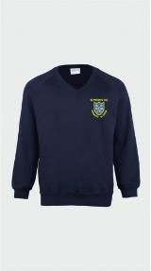  Summer / Winter | 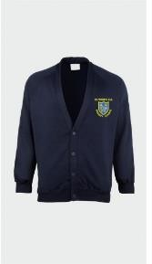  Summer / Winter | 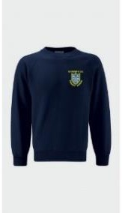  Summer / Winter | 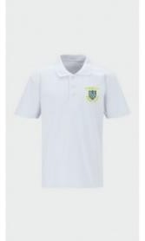  Summer / Winter
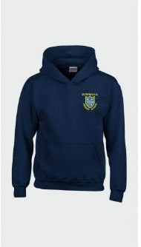  Summer / Winter | 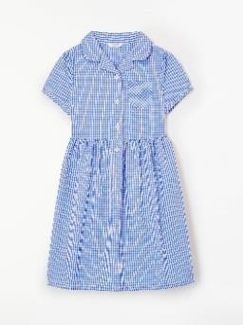  Summer | 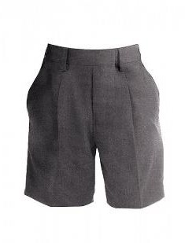  Summer | 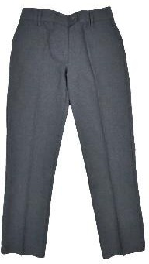  Summer / Winter
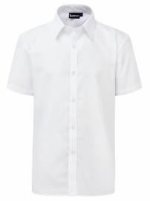  Winter | 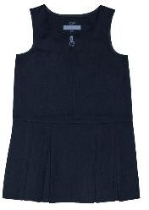  Winter | 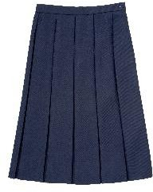  Winter | 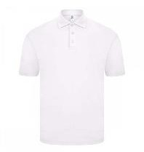  Summer / Winter
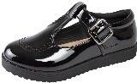  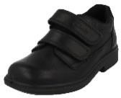  Black School Shoes | 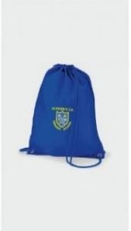  Optional PE Bag | 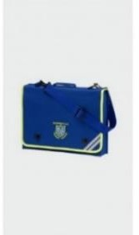  BOOK BAG | 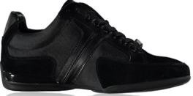  Trainers  PE FOOTWEAR
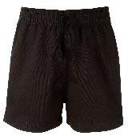  PE Kit  Plain black PE Shorts | 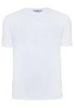  PE Kit  White T or Polo Shirt | 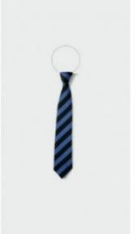

Item | Optional or  required | Branding | How to acquire
Regular school uniform
NAVY Blue Round Neck / V Neck Sweatshirt / Cardigan | Required | School logo on left-hand side | Branded sweatshirt and cardigan available from Touchline  Second hand from school if available.
Plain white short sleeved school shirt. | Required KS2 | No Branding | Available from any high street retailer
Plain white polo shirt | Required | Optional school logo on left-hand side (iron-on school logo also available) | Available from Touchline, or any high street retailer.  Second hand in school if available.
NAVY Blue school hoody | Required | Optional school logo on left-hand side (iron-on school logo also available) | Available from Touchline or any high street retailer
Grey trousers or grey skirt | Required | No branding | Available from any high street retailer
St Peter’s School Tie | Required KS2 | Blue and Black stripes from Touchline | Touchline
Sensible, plain black shoes | Required | No branding | Available from high street retailers.
SUMMER  Light blue ‘Gingham’ summer dress. | Optional | No branding | Available from high street retailers.
Navy Pinafore | Optional | No branding | Available from high street retailers

PE kit
Plain white t-shirt | Required | Optional school logo on left-hand side. | Available from Touchline or any high street retailer
Plain black shorts | Required | No logo required | Available from Touchline or any high street retailer
Accessories
School Primary Book bag | Required | Optional school logo | Available from Touchline
Drawstring PE Bag | Optional | Optional school logo on left-hand side | Available from Touchline or any high street retailer
Navy Blue School Cap | Optional | Optional school logo from Touchline | Available from Touchline or any high street retailer
Navy Blue Headband or head tie | Optional | N/A | Available from high street retailers

Trainers are not considered suitable footwear. High heels are not permitted. Skirts must be knee-length.
Parents are responsible for ensuring their child brings their PE kit to school when needed.

EYFS Uniform Requirements

Item | Required / Optional | School Logo | Supplier | Item
Plain white polo shirt | Required | School Logo Optional | Branded available from Touchline  Plain available from any High Street retailer | 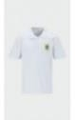
NAVY  Blue Round Neck / V Neck Sweatshirt  / Cardigan | Required | School Logo  required | Branded sweatshirt and cardigan available from Touchline | 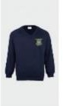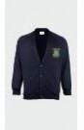
Winter Grey Trousers  Summer Shorts | Required | N/A | Plain available from any High Street retailer | 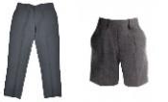
Navy Pinafore Or  Navy skirt | Required | N/A | Plain available from any High Street retailer | 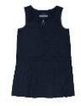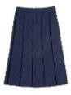
NAVY  Blue school hoody | Required | School Logo Optional | Branded available from Touchline  Plain available from any High Street retailer | 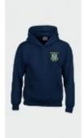
SUMMER TERM  Light blue ‘Gingham’ summer  dress. | Optional | N/A | Available from high street retailers. | 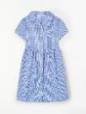
Sensible, plain black shoes. | Required | Strictly no trainer shoes | Available from high street retailers. | 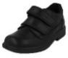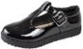
PE Kit  Black Shorts / White T - Shirt | Required | Optional | Branded available from Touchline  Plain available from any High Street retailer | 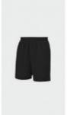

Drawstring PE Bag | Optional | Optional | Branded available from Touchline  Plain available from any High Street retailer | 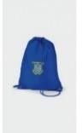
Navy Blue School Cap | Optional | Optional | Branded available from Touchline  Plain available from any High Street retailer | 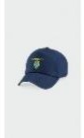

Jewellery
No jewellery is permitted in school. This includes necklaces, rings and any ear jewellery.
Watches are permitted but no smart watches that have internet, messaging or social media access.

Hairstyles
Pupils with long hair must ensure that this does not impede their vision, cover their face or provide a health and safety risk. All hair past shoulder length must be tied back.
The following hairstyles are not considered appropriate for school:
- Brightly-coloured, dyed hair.
- Headwear with bold patterns or colours.
- Excessive hair accessories.
- Line cuts in hair

Makeup
The school rules on makeup are as follows:
- False nails and nail extensions are not permitted.
- No face make up / foundation is permitted unless for medical purposes.
- Only clear nail varnish may be worn.
- Temporary tattoos are not permitted.

Adverse weather
All pupils are required to wear weather-appropriate clothing that covers as much of their skin as possible during adverse weather.
Pupils are advised not to wear any jumpers or blazers during heatwaves. If outside during break times, pupils not wearing sun-safe clothing are advised to stay in an area protected from the sun, or spare clothing is provided. Caps should be worn
For cold temperatures, this includes wearing:
  - Scarfs, gloves, coats and hats when they are outside.
  - Warm jumpers that conform to the school’s uniform policy.
  - Trousers, or thick tights with skirts.

Labelling
All pupils’ clothing and footwear is clearly labelled with their name. Any lost clothing is be taken to the lost property box

Monitoring and review
This policy is reviewed every two years by the chair of governors and the headteacher.

