Art and Design Curriculum
Year 6
KS2
- to create sketch books to record their observations and use them to review and revisit ideas
- to improve their mastery of art and design techniques, including drawing, painting and sculpture with a range of materials [for example, pencil, charcoal, paint, clay]
- about great artists, architects and designers in history.
Key stage
Autumn | Spring | Summer
Unit Title:  Colour – Self portraits | Unit Title:  Drawing – Narrative and illustration (WW2) | Unit Title:  Printing – Mono-print
Artist:  David Hockney  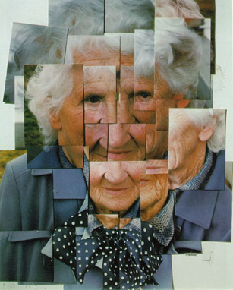 | Artist:  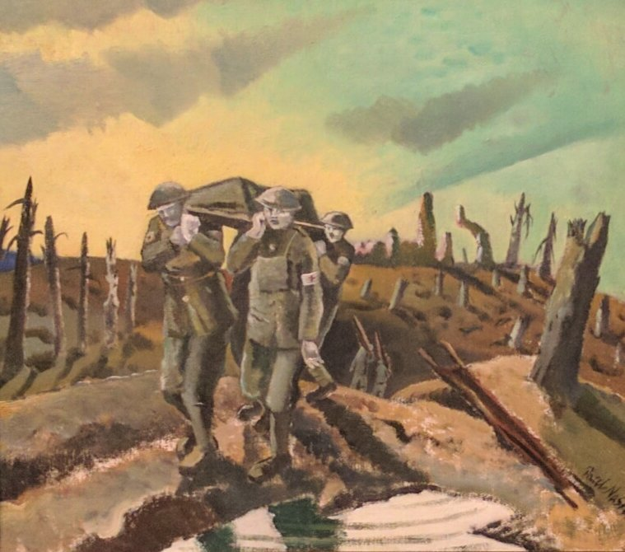  Paul Nash  War poetry – Wilfred Owen | Artist:  Elizabeth Catlett  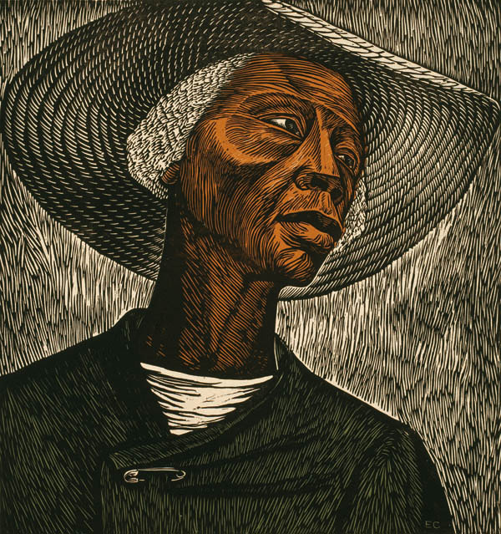
Prior Knowledge:  - To know the difference between primary and secondary colours.  - To know how to mix secondary colours.  - To know which colours complement each other.  - To know how to create different tones of a colour, from the darkest to the lightest.  - To be able to lighten the tone of a colour using white.  - To be able to darken the tone of a colour without using black.  - To be able to select appropriate colours with reference to mood.  To be able to select appropriate tools for making different marks and effects with paint.  Prior Vocabulary:  Colour, primary, secondary, tertiary, paint, mix, complementary, hue, vibrancy. | Prior Knowledge:  - To know how to hold a pencil.  - To know how to draw an enclosed shape with a pencil.  - To know how to make a representation of a subject using a pencil.  - To know a variety of marks that can be made with a pencil.  - To be able to select appropriate techniques for different parts of a drawing.  - To know how to combine pencil, coloured pencil and ink in a drawing.  - To know how to select key features for a picture.  Prior Vocabulary:  Draw, line, shape, mark, pencil, hold, size, round, straight, curved, soft, hard, light, dark, group, fluid, continuous line, angle, drawn, accurate, combine, inspire, research, abstract, features, characteristics. | Prior Knowledge:  - To know how to create a relief print by drawing in foam.  - To understand that the print will be a mirror image of the design.  - To understand that printing is a great way to create multiples of the same image.  Mono-printing  Mono-printing is a form of printmaking that has lines or images that can only be made once, unlike most printmaking, which allows for multiple originals. There are many techniques of mono-printing.  Prior Vocabulary:  Print, printing, mirror-image, colour, primary, secondary, paint, mix, complementary, design, multiple, relief print, mark-making, mixing, experiment.
Skills:  - How to match colours by mixing paint.  - Ho to paint with control and accuracy.  - How to combine photographs with paint in a final artwork. | Skills:  - How to express a narrative in a piece of artwork.  - How to consider narrative in relation to composition.  - How to interpret written stimulus into visual imagery. | Skills:  - How to mono-print  - How to combine mono-printing and drawing or painting in order to introduce colour.
Knowledge:  - To know that David Hockney is an influential British artist born in Bradford in 1937.  - To be able to recognise the painting ‘Mother’ and to know that this technique was created through experimentation with materials and processes.  - To know how to match colours by mixing paint.  - To know how to combine photographs and paint in one piece of artwork. | Knowledge:  - To know the name of the war artist Paul Nash.  - To know that Paul Nash was a British artist born in 1889 and died in 1946.  - To recognise the Paul Nash painting ‘Ashen faced medics stretcher a wounded colleague, framed by a bright sky’. | Knowledge:  - To know the name of the artist Elizabeth Catlett.  - To know that Elizabeth Catlett was an American and Mexican graphic artist and sculptor born in 1915 and died in 2012.  - To know that Catlett was famous for political art, depicting race, feminism and injustice.  - To recognise the artwork ‘The Sharecropper’.
Key moments in sketchbook:  - Artist research pages.  - Colour mixing.  - Exploring combining collage and paint in an artwork.  - Experimenting with composition.  NB – Annotation should feature throughout the sketchbooks to show the pupils’ reflections on their work and that of others. | Key moments in sketchbook:  - Artist pages – exploring the work of Paul Nash.  - Exploring drawing techniques and combinations of materials.  - Exploring key themes in Wilfred Owen Poetry through visual imagery.  - Exploring narrative in artwork.  - Experimenting with composition. | Key moments in sketchbook:  - Research pages exploring Elizabeth Catlett’s artwork.  - Experiments with mono-printing.  - Drawings of different designs.  - Exploring different compositions and combinations.  - Experimenting with printing, drawing and painting in the same artwork.  NB – Annotation should feature throughout the sketchbooks to show the pupils’ reflections on their work and that of others.
Final artwork:  A3 individual artworks combining photographs and painting. | Final artwork:  Individual A3/A4 drawings, combining drawing materials and focusing on narrative. | Final artwork:  Individual artworks.
Key Vocabulary:  Combined, match, photography. | Key Vocabulary:  Narrative, storytelling, key themes, visual imagery, interpretation. | Key Vocabulary:  Mono-print,
Curriculum links: | Curriculum links:  History – World War 1 and 2 | Curriculum links:  Social History.

