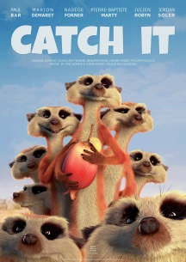
Tuesday 2nd June 2020
Catch It

Please watch this clip with your child and ask some or all of the following oral comprehension questions.
https://www.youtube.com/watch?v=c88QE6yGhfM

Pause the film after 56 seconds when all of the meerkats
have come outside.
Where are the meerkats sleeping at the beginning?
How many of them are there?
Why do you think they are sleeping huddled together?
Describe the setting outside in three sentences.
What are the meerkats looking for when they come out of hibernation?

Pause the film after 1:33 after the vulture has spotted the
fruit.
What does the fruit look like?
How do you imagine it to taste?
If the meerkats could talk, what might they say to each other as they stare at the fruit in the tree?
Why do they hide as the vulture lands on the tree?
Do you think the vulture is going to let them have the
fruit? Explain your answer.

Pause the film at 3:44 when the vulture thinks he has won.
How do the meerkats react to the vulture taking the fruit?
Which sport does their formation and actions remind you of?
Explain how they work as a team to retrieve the fruit.
Think of five words to describe the how the vulture
moves.

At the end of the clip ask...
What happened to the fruit? How? Who do you think won?

