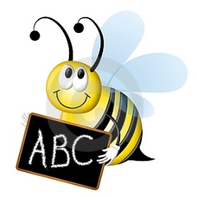
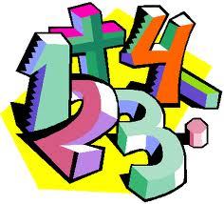
Mrs. Ainsworth
Year 2 Spellings and x tables, Summer Term 2 2020.
Wk beg. 1.6.  Contractions | Wk beg 8.6.  Suffixes  -ment  -ful | Wk beg 15.6  Suffixes  -ly  -less | Wk beg 22.6.  Suffixes  -tion | Wk beg 29.6  Common Exception Words | Wk beg 6.7.  Homo-  phones | Wk beg  13.7.  Homo-  phones
Can’t  Didn’t  Hasn’t  Couldn’t  It’s  Wouldn’t  Shouldn’t  Wasn’t  Mr.  Mrs. | Enjoyment  Sadness  Careful  Playful  Plainness  Argument  Merriment  Happiness  Plentiful  cheerful | Badly  Hopeless  Penniless  Happily  Lovely  Joyless  Slowly  Quickly  Careless  fearless | station  fiction  motion  national  section  addition  subtraction  potion  option  introduction | any  many  clothes  water  pretty  Christmas  beautiful  pretty  poor  kind | There  Their  They’re  Here  Hear  See  Sea  To  Two  to | Be  Bee  Quite  Quiet  Bear  Bare  One  Won  Sun  son
X2, X5, X10 | X2, X5, X10 | X2, X5, X10 | Division facts | Division facts | Mixed 2,5,10 x and ÷ | Mixed 2,5,10 xand ÷

