Monday 4.5 Phonics

Start with the u-e power point. Read the words.

Note that the u-e digraph has two sounds.

flute cube
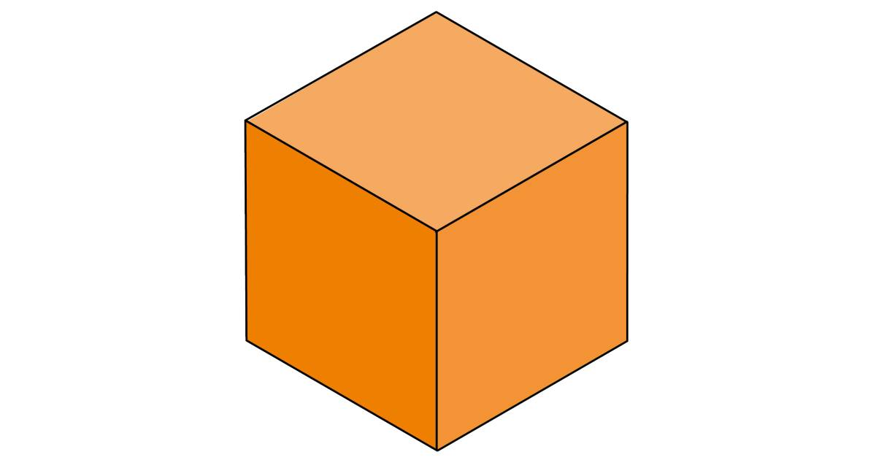

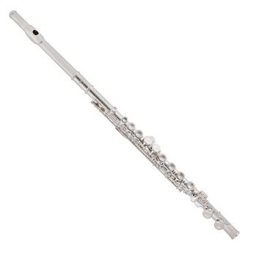

It is like an ‘oo’ sound. This is a ‘you’ sound.

When you read, try them both and see what fits best.

- Find a dice and play roll and write. The board game is attached!

