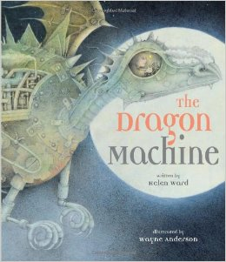
Q2.Who is the main character?
Q1.What do you think the story is about?
Q3.Do you want to read this story? Why?

Q4.How does the front cover engage you?

Q1. I think the story is about ____________________________________________
Q2.I think the main character is ___________________________________________
Q3. I want to read the story because
____________________________________________
Q4. The Front cover engages me because
____________________________________________
Now read, listen to or watch the story.
https://www.booktrust.org.uk/books-and-reading/have-some-fun/storybooks-and-games/the-dragon-machine/

https://www.youtube.com/watch?v=FVw6-4ig7eo

Discuss/Think about
Q5. Where any of your predictions correct? (It doesn’t matter if they were not!)
Q6. Did you like this story?
Q7. How is it similar and how is it different to last week’s texts?

