Wednesday 22nd April
Good morning, Y6. I hope you’re having a great week! Thanks for all the work that you’ve been sending in – keep it up! Remember also though that these are challenging times so just do what you can and be as independent as possible if parents are trying to work too!

English
Writing – today, I would like you to read through the following and plan your writing. You will have today, tomorrow and Friday to finish this task so take your time and do your best. Remember, we always try and write first drafts in school – revising and editing is important!

Main task:
Here is writing prompt that was set for a writing SAT test. First read the prompt…
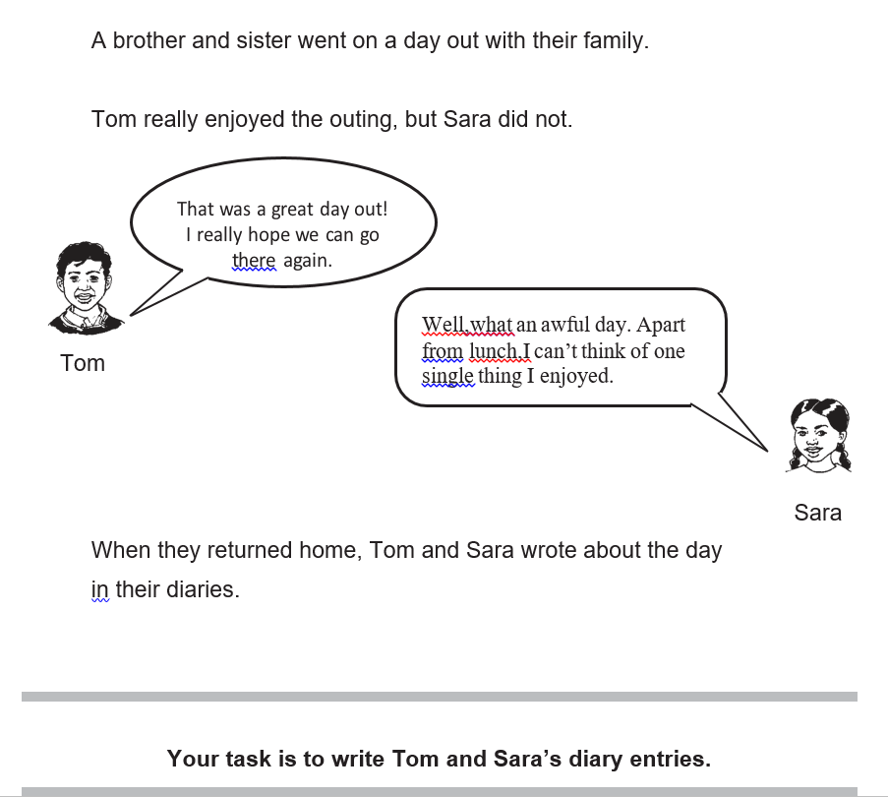

Before you start, have a look at how this child tackled the task.

Tom’s Diary
Dear Diary,
I had a great day ... I was excited as soon as I was told that we were going to the Roman museum by Mum and Dad – well I have dropped enough hints! I love history, as you know, and it was fascinating to learn all about Romans. As soon as we arrived, we got a map to see where we wanted to go, but we let our feet lead the way.
We got to build our own tapestry design on the wall out of small mosaic squares. There was also an artist impression of where the Romans actually walked on mosaics tiles! I found that really interesting – I don’t think Sara was that impressed though. Near the back of the museum, there was a wheel with the Roman alphabet on it, my name was DPV. The morning flew by, my whole family was starving, so we stopped for lunch. It was lovely, we had burgers and chips. Could this day seriously get any better!?!
It was nearly time to have a look at the other half of the museum but this time we decided to use our map. First of all, we headed off to the Roman armour room where you could see a model Roman soldier dressed in golden armour with a shield and a sword.
In the same room behind glass, there were necklaces and jewellery that had been found by archaeologists. They seemed very fragile and delicate and if touched, they would probably snap. It looked like it took ages to carve the patterns onto the real bronze. After a final stop at the gift shop where I bought a book, we headed home.
To sum up, I had a lovely, eventful day!

Sara’s Diary
Dear Diary,
I had an awful day ... we went to Roman museum, I’ve always wanted to go there! Can you tell I’m being sarcastic? It was soooo boring, I begged and pleaded not to go right from the beginning but no, it was ‘favourite child’ Tom’s turn to choose.
My feet are still hurting because we trampled round every tiny inch of the museum. I decided to cheer myself up by helping Tom build the tapestry but it just put me down even more because it was far too hard - Tom managed to do it, of course! By the time we got to write our name in Roman, I was bored stiff. What a stupid idea it was to write your name in Roman, only people from ‘Sadland’ would do that! The morning absolutely dragged.
The only highlight was the burger and chips we had for lunch – I was starving!
Then my dorky brother got the map out and the torture resumed. Oh, and to make matters worse, we stopped at EVERY SINGLE fact sheet, and there were 200 of them!
I was tired, bored and just overall FED UP! I mean we must have been the first family to stand there and look at EVERY SINGLE fact sheet, as well as looking at all of the old, crumbling artefacts and jewellery. At least I got to buy the biggest gob stopper ever in the gift shop. I wish Tom had bought one instead of a book, at least it would have kept him quiet on the drive home. I hope we never go back there again!
To sum up, I had the worst day ever!

Today you are just going to plan your diary entries in response to the task – there is a planning format below that you may find helpful to get you started.
You can decide who is the older sibling, Tom or Sara.
Once you have decided how old Tom is, you need to think what would be his perfect day out – choose something that you are able to talk about so you can describe the day in detail. If you are a boy, choose something that you would love to do, then your enthusiasm will jump off the page. If you are a girl with a brother, what would his perfect day out be?
Remember, Sara hates everything that Tom loves about the day. How does she describe the exact same activities? What would she rather be doing?
Remember that your voice/style will have to change depending on who is writing their diary – Tom or Sara. I want their different ages and personalities to be obvious when I’m reading.
Get planning Y6: the planning format below is just a suggestion – you can plan in any way that works for you!

