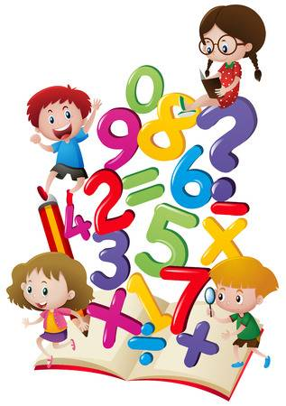**Year 2 Maths from Mrs.Ainsworth**



21.4.20

4-a-day

1. 82+??=101
2. 62-31=
3. 8 X 3 =
4. 1/3 0f 21 =

We will revise some of our work on fractions this week.

Watch this video lesson week 2, **lesson 5**

(If you wish, and have time, you could also recap some of the previous lessons)

<https://whiterosemaths.com/homelearning/year-2/>

Print and complete the worksheet (or discuss with an adult and make notes)

Check your answers on the same website.

If you can, take a photo of Monday’s and Tuesday’s Maths work to tweet (@Y2Mrsa) or email (stpetersy2@sthelens.org.uk)