Art and Design Curriculum 23-24
Year 1
KS1 – National Curriculum for Art and Design
- to use a range of materials creatively to design and make products
- to use drawing, painting and sculpture to develop and share their ideas, experiences and imagination
- to develop a wide range of art and design techniques in using colour, pattern, texture, line, shape, form and space
- about the work of a range of artists, craft makers and designers, describing the differences and similarities between different practices and disciplines, and making links to their own work

Autumn | Spring | Summer
Unit Title: Colour – Exploring seasonal changes and the harvest. | Unit Title: Drawing – Nocturnal animals | Unit Title: Printing – Natural Objects and seasonal changes
Process:  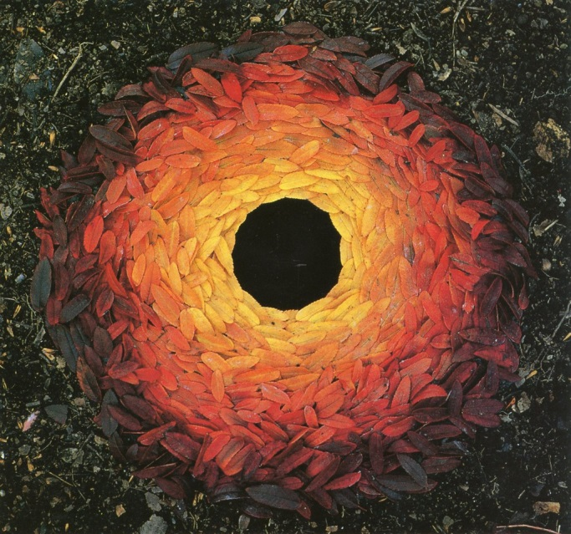  Andy Goldsworthy | 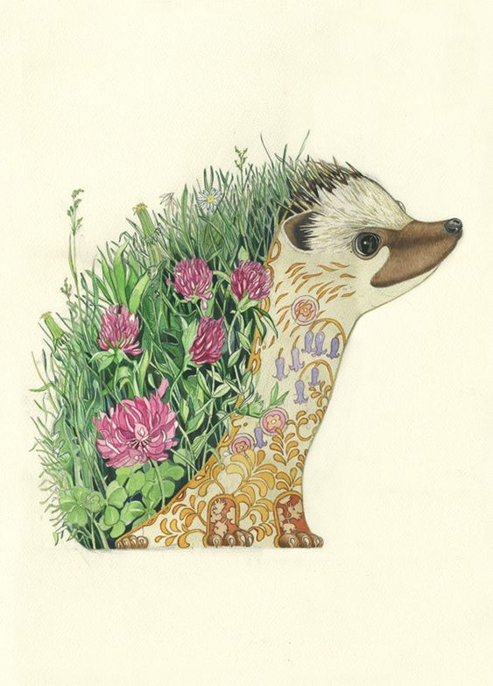  Artist:  Daniel Mackie  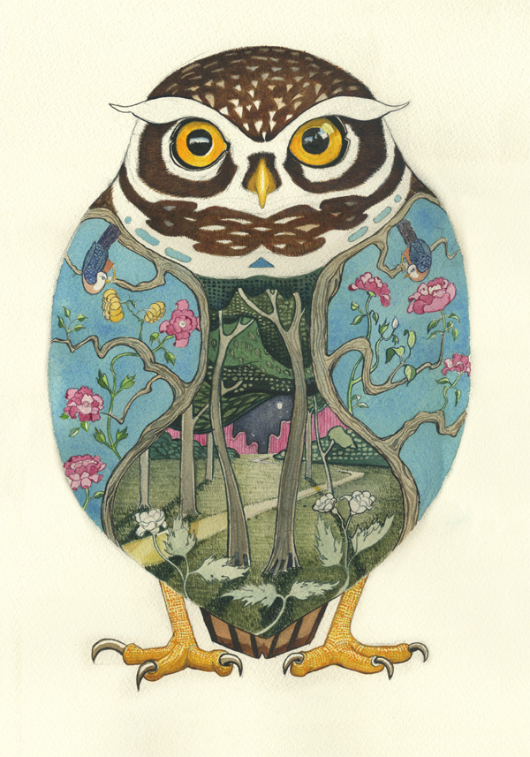 | Artist:  Hapa Zome  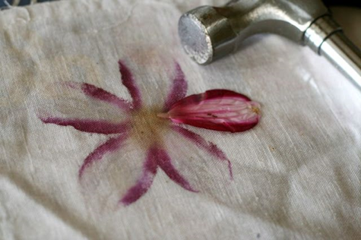  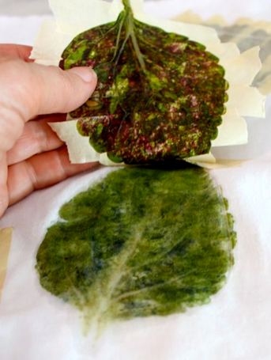
Skills:  - How to collect natural objects of a similar colour.  - How to arrange objects to create an effective composition.  - How to explore different colours in an artwork. | Skills:  - How to hold a pencil in order to make different marks (tripod grip, fist, handle-bar).  - How to make a variety of marks with a pencil such as stippling, scribbling, soft and hard.  - The effect made by drawing onto different materials.  - How to select key features for a drawing.  - How to incorporate colour into a drawing.  - How to critically reflect on a piece of artwork and suggest amendments. | Skills:  - How to create prints of natural objects using paint.  - How to create prints of plants and flowers using Hapa Zome technique.  - How to create a relief print block using found natural objects.  - How to consider the composition of a relief print.
Knowledge:  - To know what we mean by ‘Harvest’.  - To know key facts about the artist Andy Goldsworthy.  - To know the different colours associated with Autumn.  - To know how to select relevant objects for a piece of artwork. | Knowledge:  - To know key facts about the artist Daniel Mackie and his artwork.  - To know how to select key features for a picture.  - To know about a variety of animals and their habitats.  - To know the visual characteristics of different animals and their habitats. | Knowledge:  - To know about the Hapa Zome printing technique.  - To know how to make prints of objects.  - To know how to recognise texture.  - To know how to arrange objects in an effective composition.
Key moments in sketchbook:  - Artist Research pages – Andy Goldsworthy  - Exploratory drawings of natural objects.  - Collages exploring autumn and associated colours.  - Photos of temporary sculptures made outside using natural objects.  NB – Annotation should feature throughout the sketchbooks to show the pupils’ reflections on their work and that of others. | Key moments in sketchbook:  - Artist Research pages – Daniel Mackie  - Experimental marks made using coloured pencil.  - Experimenting with drawing onto different surfaces with different colours.  - Observational drawings form photos of different animals and their habitats, picking out key elements.  - Experimenting with collage, using photos and cut out images of relevant habitats arranged into animal shapes.  NB – Annotation should feature throughout the sketchbooks to show the pupils’ reflections on their work and that of others. | Key moments in sketchbook:  - Hapa Zome research pages.  - Experimental prints of natural objects using paint.  - Experimenting with printing onto different surfaces with different colours.  - Experimenting with Hapa Zome technique.  NB – Annotation should feature throughout the sketchbooks to show the pupils’ reflections on their work and that of others.
Final artwork:  Outdoor sculptures. | Final artwork:  Collaborative collage, including drawings in coloured pencil. | Final artwork:  Individual A4 sized relief blocks made using natural objects (bark, leaves, plants and flowers) arranged in a composition and printed.
Key Vocabulary:  Sculpture, objects, colour, autumn, arrange, create, similar. | Key Vocabulary:  Colour, habitat, animal, nature, shape, size. | Key Vocabulary:  Print, printing, print-making, relief print, Hapa Zome, natural ink, multiple, natural, object, texture.
Curriculum links:  English – Harvest  RE - Harvest | Curriculum links:  English – Night animals  Science - Animals | Curriculum links:  Science – seasonal changes and plants

