St Peter’s C.E. Primary School
History

Curriculum Intent

Curriculum
Learning expectations by year group

Learning expectations by year group
EYFS | Historical focus | Substantive knowledge | Disciplinary knowledge
 | My family | I know who is in my family.  I know where I fit in my family timeline.  I know the different names for the people in my family.  I am beginning to know what a family tree is. | Can I talk briefly about past events at home e.g. ‘yesterday’? Can I use past, present and future forms accurately when talking about events?  Can I name and describe familiar people?
 | Changes and growing | I know how I have changed from baby to now.  I know things I could do in the past.  I know things that I can do in the present.  I know what I want to do in the future.  I know how to talk about important times in my life and describe them. | Can I identify some similarities and differences between things in the past and now, drawing on their experiences and what has been read in class?  Can I talk briefly about past events at home e.g. ‘yesterday’? Can I use past, present and future forms accurately when talking about events?
 | Remembrance | I can talk about Norman Harvey.  I know about Norman Harvey’s bravery.  I know it is important to remember special people. | Can I talk about the lives of the people around them and their roles in society?  Can I compare and contrast characters from stories, including figures from the past.
 | Changes over time | I know how transport has changed over the years.  I know what cars and bikes were like in the past.  I know what new transport there is in the present. | Can I talk about brief differences in the past. For example, they can find out about the childhood of their grandparents?  Can I comment on images of familiar situations in the past?
 | Communication and  Alexander Graham Bell | I know how people communicated a long time ago.  I know who invented the telephone.  I know the ways that we communicate in the present.  I know how telephones have changed over time. | Can I comment on images of familiar situations  in the past?
 | Dinosaurs | I know that dinosaurs were alive in a different time.  I know the world was different in dinosaur times. | Can I say some similarities and differences between things in the past and now, drawing on their experiences and what has been read in class?
 | Changes- teddy bears | I know who made the first teddy bear.  I know how the teddy bears have changed over time.  I can talk about old and new toys.  I can describe an old bear.  I know about bears in different stories. | Can I comment on images of familiar situations in the past?  Can I compare and contrast characters from stories, including figures from the past?
 | My family | I know who is in my family.  I know where I fit in my family timeline.  I know the different names for the people in my family.  I am beginning to know what a family tree is. | Can I talk briefly about past events at home e.g. ‘yesterday’? Can I use past, present and future forms accurately when talking about events?  Can I name and describe familiar people?

 | Learning expectations by year group
Year 1 |  | Unit big question | Substantive knowledge |  | Disciplinary knowledge
 |  | How did Stephenson’s Rocket change  the world? | - I know where to place events on the timeline and use vocabulary to describe.  - I know how to describe events that have happened in my life using a timeline.  - I know how life has changed from the Victorian era to now.  - I know how to use time vocabulary to compare my timeline against the achievements of George Stephenson.  - I know why George Stephenson was important to me, our local area and the world.  - I know why Stephenson’s Rocket was successful. |  | Chronological Understanding  Can they put up to three objects in chronological order (recent history)?  Can they use words and phrases like: old, new and a long time ago?  Can they tell me about things that happened when they were little?  Can they recognise that a story that is read to them may have happened a long time ago?  Do they know that some objects belonged to the past?  Can they retell a familiar story set in the past?  Can they explain how they have changed since they were born?  Challenge- Can they put up to five objects/events in chronological order (recent history)?  Can they use words and phrases like: very old, when mummy and daddy were little?  Can they use the words before and after correctly?  Can they say why they think a story was set in the past?  Knowledge and Interpretation  Do they appreciate that some famous people have helped our lives be better today?  Can they begin to identify the main differences between old and new objects?  Can they identify objects from the past, such as vinyl record?  Challenge- Can they explain why certain objects were different in the past, e.g. iron, music systems, televisions?  Can they tell us about an important historical event that happened in the past?  Can they explain differences between past and present in their life and that of other children from a different time in history?  Historical Enquiry  Can they ask and answer questions about old and new objects?  Can they spot old and new things in a picture?  Can they answer questions using a artefact/ photograph provided?  Can they give a plausible explanation about what an object was used for in the past?  Challenge- Can they answer questions using a range of artefacts/ photographs provided?  Can they find out more about a famous person from the past and carry out some research on him or her?
 |  | How did the Great Fire of London affect us now? | - I know the events of the Great Fire of London.  - I know the cause of the Great Fire of London.  - I know why the Great Fire of London burnt down so many buildings.  - I know what improvements could have been made to reduce the spread of the fire.  - I know how people lived through the Great Fire of London.  - I know how London was rebuilt and why. |  | Chronological Understanding  Can they put up to three objects in chronological order (recent history)?  Can they use words and phrases like: old, new and a long time ago?  Can they tell me about things that happened when they were little?  Can they recognise that a story that is read to them may have happened a long time ago?  Do they know that some objects belonged to the past?  Can they retell a familiar story set in the past?  Can they explain how they have changed since they were born?  Challenge- Can they put up to five objects/events in chronological order (recent history)?  Can they use words and phrases like: very old, when mummy and daddy were little?  Can they use the words before and after correctly?  Knowledge and Interpretation  Do they appreciate that some famous people have helped our lives be better today?  Do they recognise that we celebrate certain events, such as bonfire night, because of what happened many years ago?  Do they understand that we have a queen who rules us and that Britain has had a king or queen for many years?  Can they begin to identify the main differences between old and new objects?  Can they identify objects from the past, such as vinyl record?  Challenge- Can they explain why certain objects were different in the past, e.g. iron, music systems, televisions?  Can they tell us about an important historical event that happened in the past?  Can they explain differences between past and present in their life and that of other children from a different time in history?  Do they know who will succeed the queen and how the succession works?  Historical Enquiry  Can they ask and answer questions about old and new objects?  Can they spot old and new things in a picture?  Can they answer questions using a artefact/ photograph provided?  Can they give a plausible explanation about what an object was used for in the past?  Challenge- Can they answer questions using a range of artefacts/ photographs provided?  Can they find out more about a famous person from the past and carry out some research on him or her?
 |  | How did Florence Nightingale and Mary Seacole change the way hospitals work? |  |  | Chronological Understanding  Can they put up to three objects in chronological order (recent history)?  Can they use words and phrases like: old, new and a long time ago?  Can they recognise that a story that is read to them may have happened a long time ago?  Can they explain how they have changed since they were born?  Challenge- Can they put up to five objects/events in chronological order (recent history)?  Can they use words and phrases like: very old, when mummy and daddy were little?  Can they use the words before and after correctly?  Knowledge and Interpretation  Do they appreciate that some famous people have helped our lives be better today?  Can they begin to identify the main differences between old and new objects?  Can they identify objects from the past, such as vinyl record?  Challenge- Can they explain why certain objects were different in the past, e.g. iron, music systems, televisions?  Can they tell us about an important historical event that happened in the past?  Historical Enquiry  Can they ask and answer questions about old and new objects?  Can they spot old and new things in a picture?  Can they answer questions using a artefact/ photograph provided?  Can they give a plausible explanation about what an object was used for in the past?  Challenge- Can they answer questions using a range of artefacts/ photographs provided?  Can they find out more about a famous person from the past and carry out some research on him or her?
 | Learning expectations by year group
Year 2 |  | Unit big question |  | Substantive knowledge |  | Disciplinary knowledge

 | Learning expectations by year group
Year 3 |  | Unit big question | Substantive knowledge | Disciplinary knowledge
 |  | How did life change between the Stone Age and the Iron Age? | - Hook lesson- Stone Age visit/ archaeologist.  - I know about the achievements of the prehistoric people.  - I know about the changes in housing from the Stone Age to the Iron Age.  - I know about the different methods of food collection during the Stone Age period.  - I know about the religious beliefs in the prehistoric times.  - I know houses from prehistory to present day are different and can identify the continuities and changes.  - I know how to use evidence to present an argument. | Chronological understanding  Can they describe events and periods using the words: BC, AD and decade?  Can they use a timeline within a specific time in history to set out the order things may have happened?  Can they use their mathematical knowledge to work out how long-ago events would have happened?  Challenge- Can they set out on a timeline, within a given period, what special events took place?  Knowledge and Interpretation  Can they begin to picture what life would have been like for the early settlers?  Can they suggest why certain people acted as they did in history?  Do they appreciate that the early Brits would not have communicated as we do or have eaten as we do?  Historical enquiry  Do they recognise the part that archaeologists have had in helping us understand more about what happened in the past?  Can they use various sources of evidence to answer questions?  Can they use various sources to piece together information about a period in history?  Can they use their ‘information finding’ skills in writing to help them write about historical information?  Challenge- Can they begin to use more than one source of information to bring together a conclusion about an historical event?
 |  | What was Ancient Egyptian life? | - I know where Ancient Egypt appears on a timeline and make links to Britain.  - I know why the River Nile was so important to the Ancient Egyptians.  - I know about Pharaohs and how the Ancient Egyptians wrote using hieroglyphics.  - I know about Egyptian Gods and Goddesses and Why death masks were created.  - I know about mummification and the processes in What was Ancient Egypt. (Visit to the World Museum in Liverpool.)  - I know how to reflect and discuss new learning from our trip. | Chronological understanding  Can they describe events and periods using the words: BC, AD and decade?  Can they describe events from the past using dates when things happened?  Can they use their mathematical knowledge to work out how long-ago events would have happened?  Can they describe events and periods using the words: ancient and century?  Challenge- Can they set out on a timeline, within a given period, what special events took place?  Knowledge and Interpretation  Can they suggest why certain events happened as they did in history?  Can they suggest why certain people acted as they did in history?  Historical enquiry  Do they recognise the part that archaeologists have had in helping us understand more about what happened in the past?  Can they use various sources of evidence to answer questions?  Can they use various sources to piece together information about a period in history?  Can they research a specific event from the past ?  Can they use their ‘information finding’ skills in writing to help them write about historical information?  Can they, through research, identify similarities and differences between given periods in history?  Challenge- Can they use specific search engines on the Internet to help them find information more rapidly?
 |  | How did the Roman invasion of Britain affect Newton- le- Willows?

Learning expectations by year group
Year 4 | Unit big question | Substantive knowledge | Disciplinary knowledge
 |  | - I know where the Vikings came from and why they attacked.  - I know why the Vikings gained a bad reputation.  - I know why the Vikings tried to take over the country.  - I know how recent excavations have changed our view of the Vikings.  - I know how to identify Vikings places and names on a map. | Chronological Understanding  Can they place periods of history on a timeline showing periods of time?  Can they use their mathematical skills to round up time differences into centuries and decades?  Challenge- Can they use their mathematical skills to help them work out the time differences between certain major events in history?  Knowledge and Interpretation  Can they explain how events from the past has helped shape our lives?  Do they appreciate that wars have happened from a very long time ago and they are often associated with invasion, conquering or religious differences?  Do they know that people who lived in the past cooked and travelled differently and used different weapons from ours?  Challenge- Do they appreciate that what people ate was different because of the availability of different sources of food?  Do they appreciate that weapons will have changed by the developments and inventions that would have occurred within a given time?  Historical Enquiry  Can they research what it was like for a child in a given period from the past and use photographs and illustrations to present their findings?  Can they give more than one reason to support a historical argument?  Can they communicate knowledge and understanding orally and in writing and offer points of view based upon what they have found out?  Challenge:  Can they independently, or as part of a group, present an aspect they have researched about a given period of history using multi-media skills when doing so?
 | How did Anglo Saxon and Scott invasions affect our island? | - I know why the Anglo-Saxons invaded and know where they settled.  - I know about the mystery of the empty grave.  - I know how people’s lives changed when Christianity came to Britain.  - I know how the Saxons were able to see off the Viking threat.  - I know about King Alfred’s main achievements.  - I know about law and order/ punishments in Saxon times. | Chronological Understanding  Can they place periods of history on a timeline showing periods of time?  Challenge- Can they begin to build up a picture of what main events happened in Britain/ the world during different centuries?  Knowledge and Interpretation  Can they explain how events from the past has helped shape our lives?  Do they appreciate that wars have happened from a very long time ago and they are often associated with invasion, conquering or religious differences?  Do they know that people who lived in the past cooked and travelled differently and used different weapons from ours?  Do they recognise that the lives of wealthy people were very different from those of poor people?  Challenge-Can they recognise that people’s way of life in the past was dictated by their work?  Do they appreciate that wealthy people would have had a very different way of living which would have impacted upon their health and education?  Historical Enquiry  Can they research two versions of an event and say how they differ?  Can they give more than one reason to support a historical argument?  Can they communicate knowledge and understanding orally and in writing and offer points of view based upon what they have found out?  Challenge-Can they independently, or as part of a group, present an aspect they have researched about a given period of history using multi-media skills when doing so?
1. I know about Henry VIII’s life from his portraits.
2. I know why Henry
3. I know
4. I know

 | Learning expectations by year group
Year 5 |  | Unit big question | Substantive knowledge | Disciplinary knowledge
 |  | How did the Greeks influence our lives today? | - I know where events belong on a timeline using correct spacing.  - I know key events that took place between 800BCE and 146BCE.  - I know how to record information found from primary and secondary sources.  - I know how to ask and develop appropriate historical question.  - I know how to use artefacts to answer questions I have.  - I know the world impact that the Ancient Greeks made | Chronological Understanding  Can they use dates and historical language in their work?  Can they use their mathematical skills to work exact time scales and differences as need be?  Challenge- Do they appreciate that some ancient civilizations showed greater advancements than people who lived centuries after them?  Knowledge and Understanding  Can they summarise what Britain may have learned from other countries and civilizations through time gone by and more recently?  Can they explain how events from the past has helped shape our lives?  Historical Enquiry  Can they test out a hypothesis in order to answer a question?  Do they appreciate how historical artefacts have helped us understand more about British lives in the present and past?  Challenge- Can they pose and answer their own historical questions?
 |  | What was life like in Victorian Newton-le-Willows? (Local History Study) | - I know where key Victorian events belong on a timeline using correct spacing.  - I know the differences and similarities since Victorian times in Newton-le-Willows.  - I know which significant events in history have helped shape the country we have today. (Railway and Southport)  - I know which significant events in history have helped shape the country we have today. (Impact of local area and inventions)  - I know how to make comparisons between historical periods; explaining things that have changed and things which have stayed the same.  - Complete findings from the previous week. | Chronological Understanding  Can they use dates and historical language in their work?  Can they draw a timeline with different time periods outlined which show different information, such as, periods of history, when famous people lived, etc.?  Challenge- Can they create timelines which outline the development of specific features, such as medicine, weaponry, transport etc.  Knowledge and Understanding  Can they make comparisons between historical periods; explaining things that have changed and things which have stayed the same?  Do they appreciate that significant events in history have helped shape the country we have today?  Challenge- Can they appreciate how Britain once had an Empire and how that has helped or hindered our relationship with a number of countries today?  Historical Enquiry  Can children use digital mapping to compare to different historical eras to identify changes in our local area?
 |  | Compare and contrast  What is the legacy of the Maya and Anglo-Saxon cultures in their modern countries? | - I know and can compare the achievements of the Maya civilisation and Anglo Saxon.  - I know the similarities and differences between Norman and Spanish invasions of Anglo-Saxon and Maya land.  - I know the main periods of the Maya civilization. (Timeline)  - I know how to record information found from primary and secondary sources.  - I know how to present knowledge of the legacy of the Maya civilisation. | Chronological Understanding  Can they use dates and historical language in their work?  Knowledge and Understanding  Can they describe historical events from the different period/s they are studying/have studied?  Can they summarise what Britain may have learned from other countries and civilizations through time gone by and more recently?  Historical Enquiry  Challenge- Can they suggest why there may be different interpretations of events?

Learning expectations by year group
Year 6 | Unit big question | Substantive knowledge | Disciplinary knowledge
 | Why did we have to leave? (Evacuees) | - I know why Britain went to war.  - I know why children had to be evacuated.  - I know how Britain stood firm against the German threat  - I know how Britain rationed food.  - I know that the effect of the war on British people can be shown using sources.  - I know what Christmas was like on the Home Front. | Chronological understanding  Can they say where a period of history fits on a timeline?  Can they place a specific event on a timeline by decade?  Can they place features of historical events and people from past societies and periods in a chronological framework?  Knowledge and interpretation  Can they summarise the main events from a specific period in history, explaining the order in which key events happened?  Can they summarise how Britain has had a major influence on world history?  Historical enquiry  Can they describe a key event from Britain’s past using a range of evidence from different sources?  Can they identify and explain their understanding of propaganda?
 | How did the Early Islamic State impact the world? | - I know why we should study the Ancient Islamic Empire.  - I know how the Islamic civilization spread so far, so quickly.  - I know that we can use the city of Baghdad to teach us about the early Islamic civilization.  - I know what was so special about Baghdad in its Golden Age.  - I know what life was like in both Baghdad and Cordoba.  - I know which of the early Islamic achievements has most effect on my life today. | Chronological understanding  Can they say where a period of history fits on a timeline?  Can they place a specific event on a timeline by decade?  Can they place features of historical events and people from past societies and periods in a chronological framework?  Knowledge and interpretation  Can they summarise what Britain may have learned from other countries and civilizations through time gone by and more recently?  Historical enquiry  Challenge  Do they appreciate that some ancient civilizations showed greater advancements than people who lived centuries after them?  Can they suggest why there may be different interpretations of events? Maybe?
 | Coal mining in St. Helens |  | Chronological understanding  Can they say where a period of history fits on a timeline?  Can they place a specific event on a timeline by decade?  Can they place features of historical events and people from past societies and periods in a chronological framework?  Knowledge and interpretation  Can they recognise and describe differences and similarities/ changes and continuity between different periods of history? Maybe?  Historical enquiry  Can they look at two different versions and say how the author may be attempting to persuade or give a specific viewpoint? View of coal mining?  Challenge- Can they suggest why there may be different interpretations of events? Maybe?

Curriculum
Learning expectations by key concept

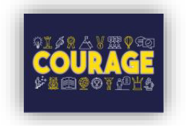
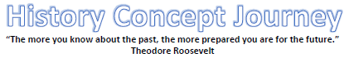

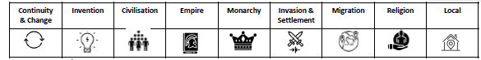

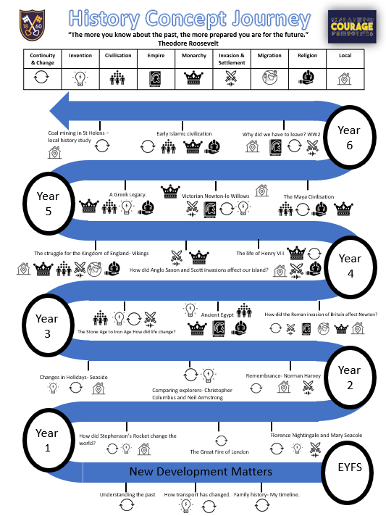
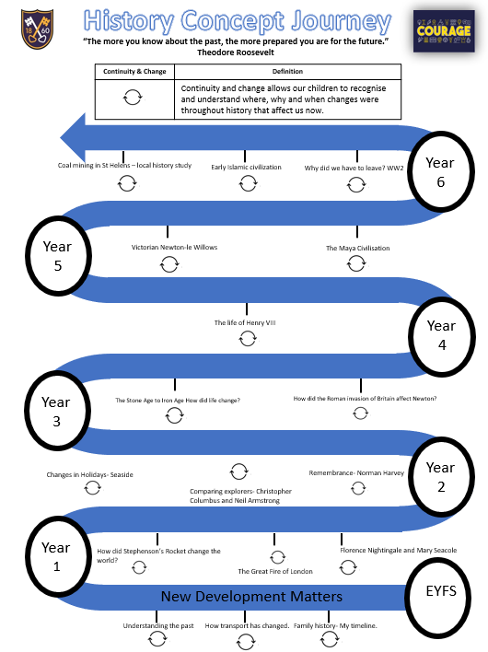
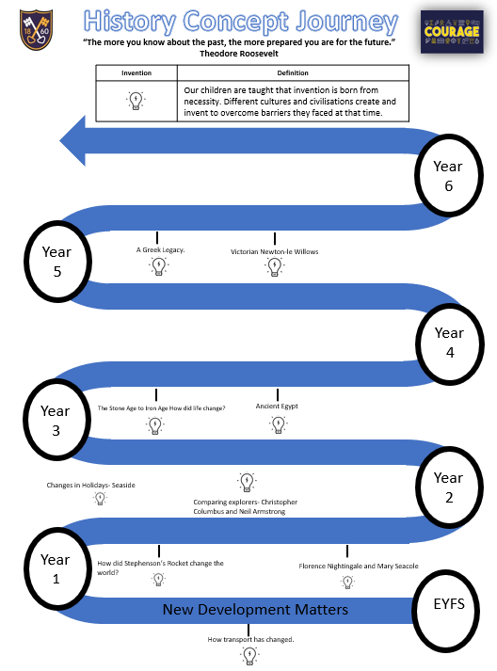
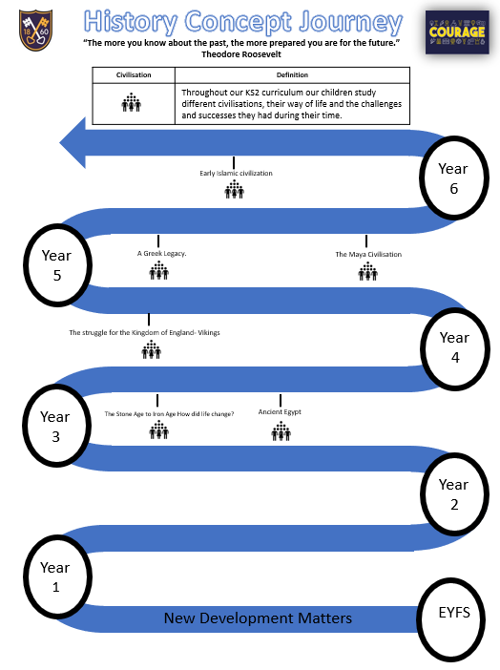
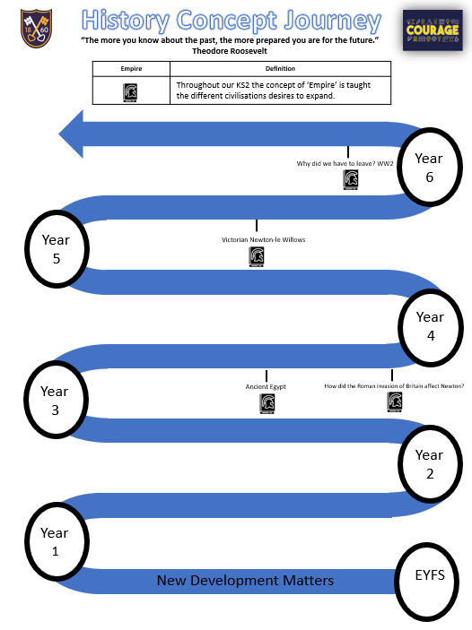
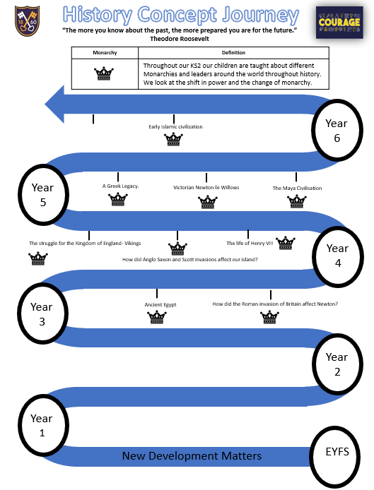
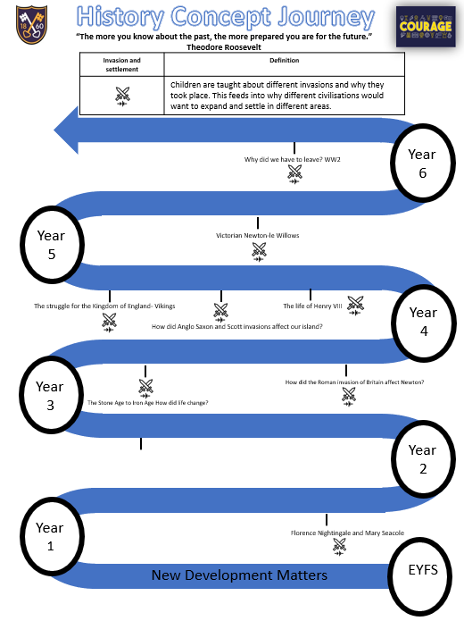
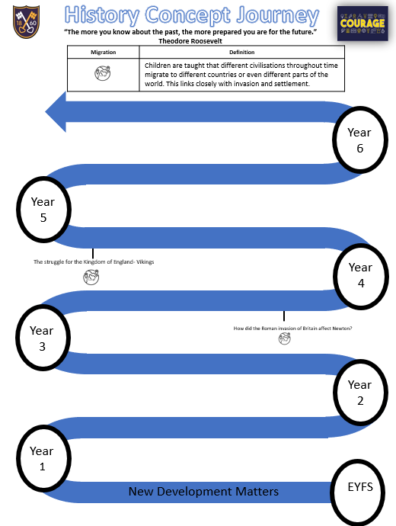
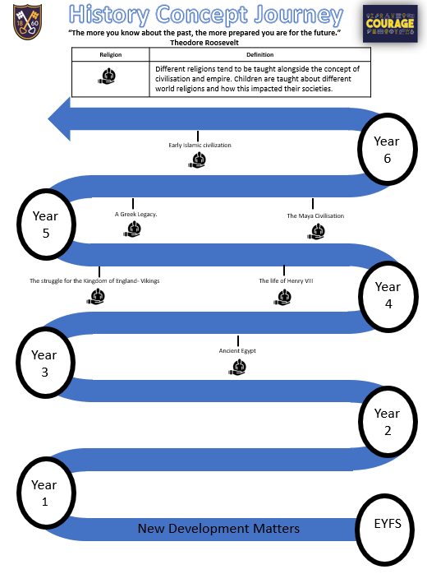
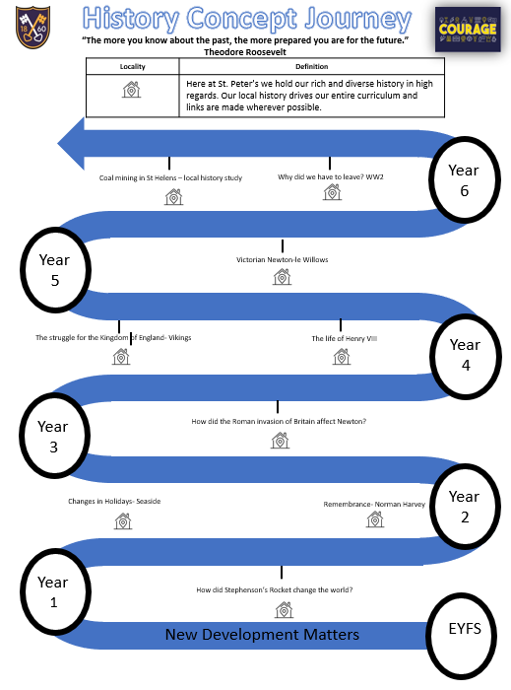

Curriculum
School intent links

EYFS | School intent
My family | St. Peter’s Family  Church Family and baptism  Wider Community.
Changes and growing | Where they were born.
Remembrance | Norman Harvey
Changes over time | Local Intentions- trains  glass
Communication | Changes family will see over time
Alexander Graham Bell | Technology at home and school
Dinosaurs
Changes- teddy bears | Changes over time- family toys

Year 1 | School intent
How did Stephenson’s Rocket changed the world? | Rainhill Train Station  Liverpool Manchester rail link running through Newton- le- Willows station.  Impact of locomotives on local industry.
How did the Great Fire of London affect us now? | Improvement in housing.  Improvements in the fire services.
How did Florence Nightingale and Mary Seacole change the way hospitals work? | Change in hospitals.  Standards of health and hygiene.

Year 2 | School intent
What is Remembrance?  Norman Harvey | Norman Harvey- VC recipient.  Norman Harvey attended our school as a pupil.
How has the seaside changed through the times?  (1900/50- Present) | Links to local area- Southport  Links to Geography units of study
Journey into the great unknown.  Neil Armstrong & Christopher Columbus | The impact travel and exploration had upon us and the improvement of technology.

Year 3 | School intent
How did life change between the Stone Age and the Iron Age? | Along the M62 7,000-year-old evidence of Stone Age settlements at Huyton on Merseyside – the earliest signs of human activity ever discovered in the area.
How was life different in Ancient Egypt different to Britain during the same time period? | British explorer and archaeologist Howard Carter discovered Tutankhamun.
How did the Roman invasion of Britain affect Newton- le- Willows? | The Roman amphitheatre at Chester was the largest in Britain.  The city of Chester was not just a small fort, the Romans meant to stay, building a city for their 20th Legion.  A 19th century Roman road runs through Newton- le- Willows from Vulcan Village to Warrington.

Year 4 | School intent
Saxon settlements were built locally to protect against the Vikings invaders.
Castle Hill is Saxon settlement less than ½ a mile from our school.

How did Anglo Saxon and Scott invasions affect our island? | Saxon settlements were built locally to protect against the Vikings invaders.  Castle Hill is Saxon settlement less than ½ a mile from our school.
Our school is Church of England, created by Henry VIII.
Our Church is built upon the reformation brought about by Henry VIII
Catherine was born about 1512, either in Parr, St Helens, or Blackfriars, London.

Year 5 | School intent
How did the Greeks influence our lives today? | In 776BC, the first Olympic Games were held in Olympia in honour of the Zeus.  Even after 3,000 years, we're still using ancient Greek ideas in maths, science and art.  Our alphabet is based on the Greek one.  The king, Alexander the Great, led his army to take over Greece, Persia, Egypt and even part of India. Wherever he went, Alexander took Greek ideas.  After he died, the Romans took over. They liked the Greeks' way of life and carried Greek ideas to even more countries - including ours!
What was life like in Victorian Newton-le-Willows? (Local History Study) | Our school was built in Victorian times and this unit will give us more knowledge about this.  Newton-le- Willows is steeped in a rich history with strong railway links that made our area significant for many reasons in Victorian times e.g. McCorquodale’s – printers for the Victorian railway, expansion of local railway links.  Our church was developed further within Victorian times with the addition of the bell tower.  Norman Harvey VC is an ex-pupil of St. Peter’s. He was born in Victorian times in Newton-le-Willows and went on to be awarded the Victoria Cross in World War 1.
Compare and contrast  What is the legacy of the Maya and Anglo-Saxon cultures in their modern countries? | Newton-le- Willows is within what would have been one of the 7 Anglo-Saxon kingdoms: Northumbria.  The Maya civilisation affected us in many ways:  - They grew crops such as corn, beans and squash in difficult conditions  - They built elaborate cities without modern machinery.  - They communicated using one of the world's first written languages.  - They measured time using calendar systems.

Year 6 | School intent
Why did we have to leave? (Evacuees) | Local Hero and Victoria Cross recipient, Norman Harvey, died in conflict during WW2.  Norman Harvey was a pupil at our school.
How did the Early Islamic State impact the world? | Local Mosque- Iman Trust  Influence of Early Islamic developments on modern day life.  Arabic numerals
Coal Mining- St Helens. | 1829 – Stephenson’s ‘Rocket’ wins the Rainhill Trials.  1830 - Newton Bridge Station , as it was originally known, opened and was one of the original stations on the Liverpool and Manchester Railway.

Curriculum
School vocabulary links (vertical and horizontal links identified)

Vocabulary
Vocabulary Y1
Stephenson’s Rocket- Transport over time. |  | Great Fire of London | Florence Nightingale Mary Seacole comparison
Transport  Locomotive  Steam Engine  Industry  Rainhill Trials  Georgian Era |  | Bakery  Firebreak  Samuel Pepys  Fire Brigade  St. Paul’s Cathedral  Water squirt  Drought  River Thames | Crimean War  Nurse  Hospital  World War One  Allies  Treason  Royal Red Cross  Lady with the Lamp
Cross Curricular Vocabulary
Year 1
A long time ago Present Now Old
When I was younger Then After Object
Before I was born Yesterday Before Event
Last week Past New Next
Vocabulary Y2
Remembrance |  | Great Explorers Comparison- Columbus and Armstrong | Changes in the seaside
Armistice  Front line  Trenches  Norman Harvey  Home front  Poppy  World War One  Allies  Victoria Cross |  | Space Race  Voyage  Explorer  Continent  Santa Maria  Astronaut  NASA  Apollo  Merchant | Bathing machine  Entertainment  Pier  Promenade  Punch and Judy  Band stand
Cross Curricular Vocabulary
Year 2
Timeline Century Decade During
Historical Modern Recently Account
Artefact Chronological Event Sequence
Evidence Historian Museum Source
Vocabulary Y3
Stone Age to Iron Age | Romans |  | Ancient Egypt
Neolithic  Prehistoric  Archaeology  Cave art  Hunters  Gatherers  Artefact  Fossil  Hillforts  Settlements  Druids  Wattle and Daub  Celts Smithing  Roundhouses Furnace | Centurion  Emperor  Aqueduct  Gladiator  Londinium  Conquer  Invasion  Invader  Romanisation  Senate  Roman Baths |  | Ancient  Civilisation  Sarcophagus  Mummification  Papyrus  Hieroglyphs  Pyramid  Pharaoh  Archaeology
Cross Curricular Vocabulary
Ancient Timeline Time period

BC/AD Century Date

Era In the…. century/decade

Vocabulary Y4
Vikings | Anglo Saxons and the Scotts | Tudors- Henry VIII
Archaeology  Vicious  Raids  Longhouse  Berserkers  Long ship  Odin  Scandinavia  Invasion  Invaders | Great Britain  Settler  Invader  Picts  Scots  Coins  Sutton Hoo Helmet  Runes  Invasion | Catholic  Protestant  Divorce  Monarch  Reformation  Beheading  Treason
Cross Curricular Vocabulary
Primary source Reliable source Secondary source
Evidence Eye-witness Chronology/chronologically
Ancient BC/AD Century
Date Era First-hand account
In the…. century/decade Time period Timeline
Enquiry Evaluate Conclusion
Vocabulary Y5
Ancient Greece | Maya | Local Victorian
Acropolis  Citizen  City State  Democracy  Empire  Olympic Games  Parthenon | Astronomy  Christopher Columbus  Hieroglyphs  Pok-a-Tok  Pyramid  Logogram  Mesoamerica | Industrial Revolution  Industry  Locomotives  National  Rainhill Trials  Victoria Cross  Vulcan Works
Cross Curricular Vocabulary
Change Citizen Continuity Ancient
Cultural Empire Legacy Archaeology/archaeologist
Monarch(y) Peasantry Social Conquest
Architecture Civilisation Democracy War
Government Parliament Political Reliability
Discoveries Enemies Excavate Bias
Peace Enquiry Evaluate Evidence
Interpretation Primary source Secondary source

Vocabulary Y6
WW2 | Early Islamic Civilisation | Local History- Coal mining
Evacuation  Evacuee  Allied Forces/ powers  Billet  Invasion  Occupation  Ghetto  Propaganda  Liberation | Islam  Caliph  Dynasty  Scholar  Vegetal  Geometric  Silk Road
Cross Curricular Vocabulary
Citizen Continuity Cultural Ancient
Empire Legacy Monarch(y) Immigration
Peasantry Social Architecture Parliament
Civilisation Democracy Government Political

